Date: 13/04/26
📊 Final Count:
🟢 Bullish | 147
🔴 Bearish | 22
Total | 169

🟢 BULLISH TRADES --- 147
1 | OIL26AprFUT
2 | ADANIENSOL26AprFUT
3 | ADANIENT26AprFUT
4 | ADANIGREEN26AprFUT
5 | APOLLOHOSP26AprFUT
6 | ASIANPAINT26AprFUT
7 | AXISBANK26AprFUT
8 | BAJFINANCE26AprFUT
9 | BHARTIARTL26AprFUT
10 | BOSCHLTD26AprFUT
11 | DLF26AprFUT
12 | DIXON26AprFUT
13 | GAIL26AprFUT
14 | HDFCLIFE26AprFUT
15 | ICICIBANK26AprFUT
16 | INOXWIND26AprFUT
17 | LT26AprFUT
18 | MUTHOOTFIN26AprFUT
19 | NTPC26AprFUT
20 | PIDILITIND26AprFUT
21 | SBICARD26AprFUT
22 | SAMMAANCAP26AprFUT
23 | SUZLON26AprFUT
24 | TATAPOWER26AprFUT
25 | PHOENIXLTD26AprFUT
26 | TORNTPOWER26AprFUT
27 | UNITDSPR26AprFUT
28 | IDEA26AprFUT
29 | AUBANK26AprFUT
30 | ADANIPORTS26AprFUT
31 | ABCAPITAL26AprFUT
32 | ALKEM26AprFUT
33 | AMBUJACEM26AprFUT
34 | ASTRAL26AprFUT
35 | AUROPHARMA26AprFUT
36 | BAJAJ-AUTO26AprFUT
37 | BHEL26AprFUT
38 | CANBK26AprFUT
39 | CDSL26AprFUT
40 | COLPAL26AprFUT
41 | CONCOR26AprFUT
42 | DALBHARAT26AprFUT
43 | DELHIVERY26AprFUT
44 | DRREDDY26AprFUT
45 | EXIDEIND26AprFUT
46 | NYKAA26AprFUT
47 | HEROMOTOCO26AprFUT
48 | ICICIGI26AprFUT
49 | PFC26AprFUT
50 | POWERGRID26AprFUT
51 | PRESTIGE26AprFUT
52 | PNB26AprFUT
53 | SBILIFE26AprFUT
54 | SHREECEM26AprFUT
55 | SHRIRAMFIN26AprFUT
56 | SAIL26AprFUT
57 | TATAELXSI26AprFUT
58 | TMPV26AprFUT
59 | INDHOTEL26AprFUT
60 | TORNTPHARM26AprFUT
61 | TRENT26AprFUT
62 | TIINDIA26AprFUT
63 | UNIONBANK26AprFUT
64 | VBL26AprFUT
65 | YESBANK26AprFUT
66 | ABB26AprFUT
67 | BSE26AprFUT
68 | BDL26AprFUT
69 | BEL26AprFUT
70 | CAMS26AprFUT
71 | DIVISLAB26AprFUT
72 | GODREJPROP26AprFUT
73 | HDFCAMC26AprFUT
74 | HDFCBANK26AprFUT
75 | ICICIPRULI26AprFUT
76 | IDFCFIRSTB26AprFUT
77 | INDIANB26AprFUT
78 | IEX26AprFUT
79 | IRFC26AprFUT
80 | IREDA26AprFUT
81 | JSWSTEEL26AprFUT
82 | JUBLFOOD26AprFUT
83 | KEI26AprFUT
84 | KAYNES26AprFUT
85 | LAURUSLABS26AprFUT
86 | PIIND26AprFUT
87 | PAGEIND26AprFUT
88 | PPLPHARMA26AprFUT
89 | RECLTD26AprFUT
90 | SOLARINDS26AprFUT
91 | SONACOMS26AprFUT
92 | TATATECH26AprFUT
93 | FEDERALBNK26AprFUT
94 | ZYDUSLIFE26AprFUT
95 | 360ONE26AprFUT
96 | BAJAJFINSV26AprFUT
97 | BANDHANBNK26AprFUT
98 | CGPOWER26AprFUT
99 | HINDALCO26AprFUT
100 | HINDZINC26AprFUT
101 | JINDALSTEL26AprFUT
102 | LTF26AprFUT
103 | LICI26AprFUT
104 | LODHA26AprFUT
105 | MANKIND26AprFUT
106 | MFSL26AprFUT
107 | MAZDOCK26AprFUT
108 | MCX26AprFUT
109 | NBCC26AprFUT
110 | NMDC26AprFUT
111 | NATIONALUM26AprFUT
112 | OBEROIRLTY26AprFUT
113 | PAYTM26AprFUT
114 | OFSS26AprFUT
115 | PGEL26AprFUT
116 | MOTHERSON26AprFUT
117 | SIEMENS26AprFUT
118 | TATACONSUM26AprFUT
119 | ULTRACEMCO26AprFUT
120 | VEDL26AprFUT
121 | ASHOKLEY26AprFUT
122 | DABUR26AprFUT
123 | HAL26AprFUT
124 | M&M26AprFUT
125 | NUVAMA26AprFUT
126 | ANGELONE26AprFUT
127 | BHARATFORG26AprFUT
128 | EICHERMOT26AprFUT
129 | FORTIS26AprFUT
130 | MARICO26AprFUT
131 | PERSISTENT26AprFUT
132 | TVSMOTOR26AprFUT
133 | TITAN26AprFUT
134 | POWERINDIA26AprFUT
135 | NESTLEIND26AprFUT
136 | AMBER26AprFUT
137 | CUMMINSIND26AprFUT
138 | KALYANKJIL26AprFUT
139 | SRF26AprFUT
140 | KPITTECH26AprFUT
141 | MANAPPURAM26AprFUT
142 | RVNL26AprFUT
143 | BLUESTARCO26AprFUT
144 | TATASTEEL26AprFUT
145 | INDUSTOWER26AprFUT
146 | NHPC26AprFUT
147 | JSWENERGY26AprFUT
🔴 BEARISH TRADES --- 22
1 | COFORGE26AprFUT
2 | INFY26AprFUT
3 | SUNPHARMA26AprFUT
4 | TCS26AprFUT
5 | TECHM26AprFUT
6 | PATANJALI26AprFUT
7 | ONGC26AprFUT
8 | IOC26AprFUT
9 | LICHSGFIN26AprFUT
10 | INDUSINDBK26AprFUT
11 | INDIGO26AprFUT
12 | UNOMINDA26AprFUT
13 | BANKINDIA26AprFUT
14 | KOTAKBANK26AprFUT
15 | CIPLA26AprFUT
16 | COALINDIA26AprFUT
17 | HINDPETRO26AprFUT
18 | POLICYBZR26AprFUT
19 | BIOCON26AprFUT
20 | MARUTI26AprFUT
21 | PETRONET26AprFUT
22 | RELIANCE26AprFUT

Trade Taken
🟢 BULLISH SIGNAL --- ADANIENSOL26AprFUT

Nifty Bias : 🔴 SHORT — Counter Trend ⚠️
Crossover : 2026-04-06 10:45 (7 days ago)
Pullback : 2026-04-13 09:15
Low ₹1118.05 ≤ EMA9(Low) ₹1143
High ₹1147.3 (breakout level)
Confirm : 2026-04-13 09:30 (+1 candle)
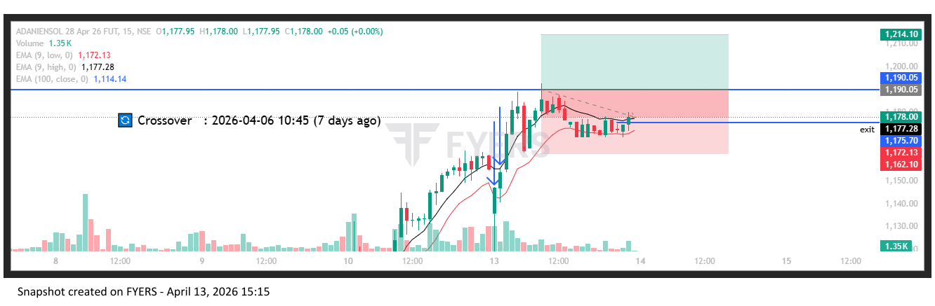
🟢 BULLISH SIGNAL --- ADANIENT26AprFUT

Nifty Bias : 🔴 SHORT — Counter Trend ⚠️
Crossover : 2026-04-06 12:00 (7 days ago)
Pullback : 2026-04-13 09:15
Low ₹2011 ≤ EMA9(Low) ₹2072.87
High ₹2080.7 (breakout level)
Confirm : 2026-04-13 09:30 (+1 candle)
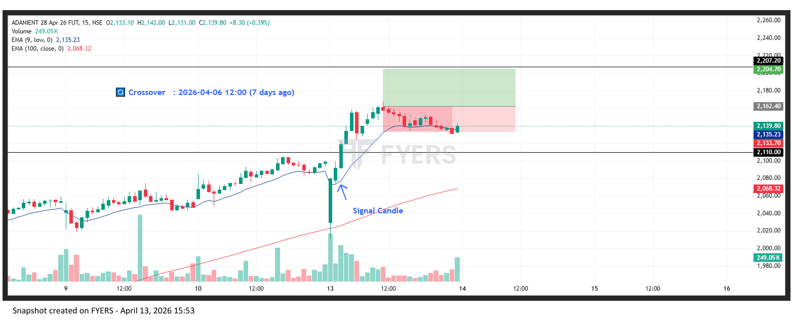
🟢 BULLISH SIGNAL --- HDFCLIFE26AprFUT

Nifty Bias : 🔴 SHORT — Counter Trend ⚠️
Crossover : 2026-04-10 09:30 (3 days ago)
Pullback : 2026-04-13 09:15
Low ₹596.15 ≤ EMA9(Low) ₹600.21
High ₹602.6 (breakout level)
Confirm : 2026-04-13 09:30 (+1 candle)
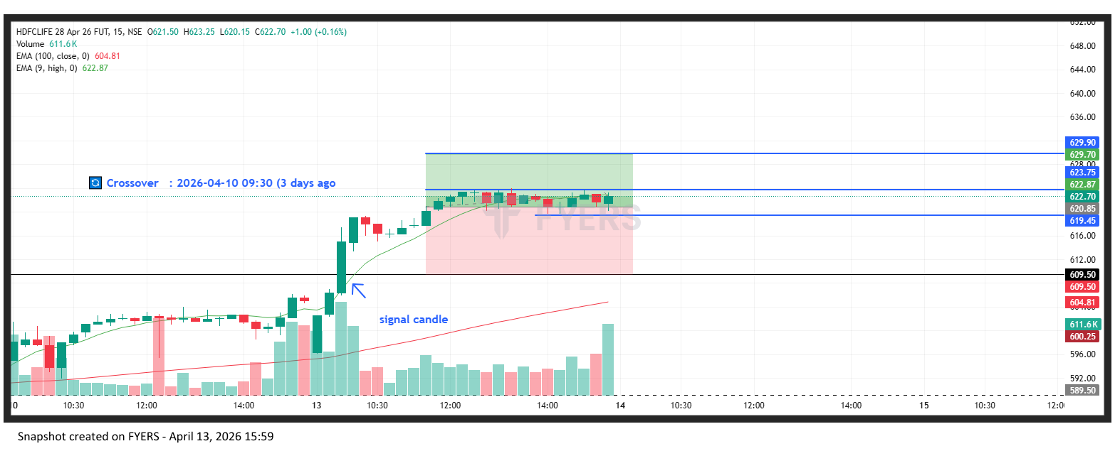
🟢 BULLISH SIGNAL --- NTPC26AprFUT

Nifty Bias : 🔴 SHORT — Counter Trend ⚠️
Crossover : 2026-04-07 10:15 (6 days ago)
Pullback : 2026-04-13 09:15
Low ₹375.7 ≤ EMA9(Low) ₹378.02
High ₹380.7 (breakout level)
Confirm : 2026-04-13 09:30 (+1 candle)
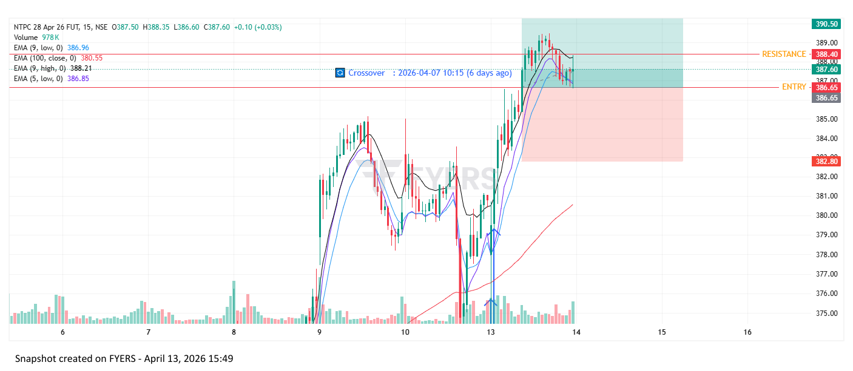
🟢 BULLISH SIGNAL --- TATAPOWER26AprFUT

Nifty Bias : 🔴 SHORT — Counter Trend ⚠️
Crossover : 2026-04-06 14:00 (7 days ago)
Pullback : 2026-04-13 09:15
Low ₹392.15 ≤ EMA9(Low) ₹397.03
High ₹400.8 (breakout level)
Confirm : 2026-04-13 09:30 (+1 candle)
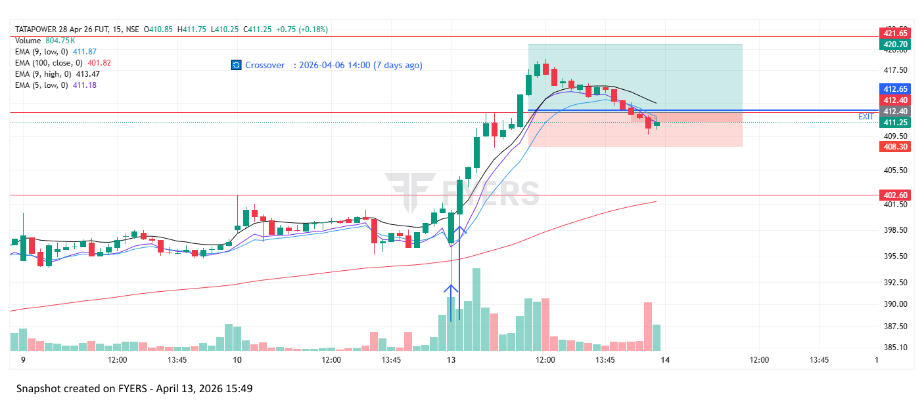
🟢 BULLISH SIGNAL --- BHEL26AprFUT

Nifty Bias : 🔴 SHORT — Counter Trend ⚠️
Crossover : 2026-04-07 13:45 (6 days ago)
Pullback : 2026-04-13 09:15
Low ₹277.39 ≤ EMA9(Low) ₹282.74
High ₹283 (breakout level)
Confirm : 2026-04-13 09:45 (+2 candle)
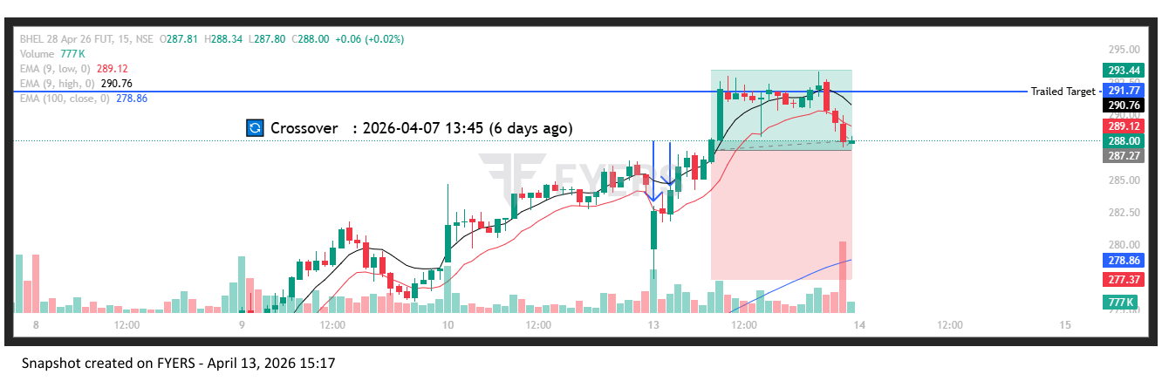
🟢 BULLISH SIGNAL --- EXIDEIND26AprFUT

Nifty Bias : 🔴 SHORT — Counter Trend ⚠️
Crossover : 2026-04-08 09:15 (5 days ago)
Pullback : 2026-04-13 09:15
Low ₹314.1 ≤ EMA9(Low) ₹322.45
High ₹322.7 (breakout level)
Confirm : 2026-04-13 09:45 (+2 candle)
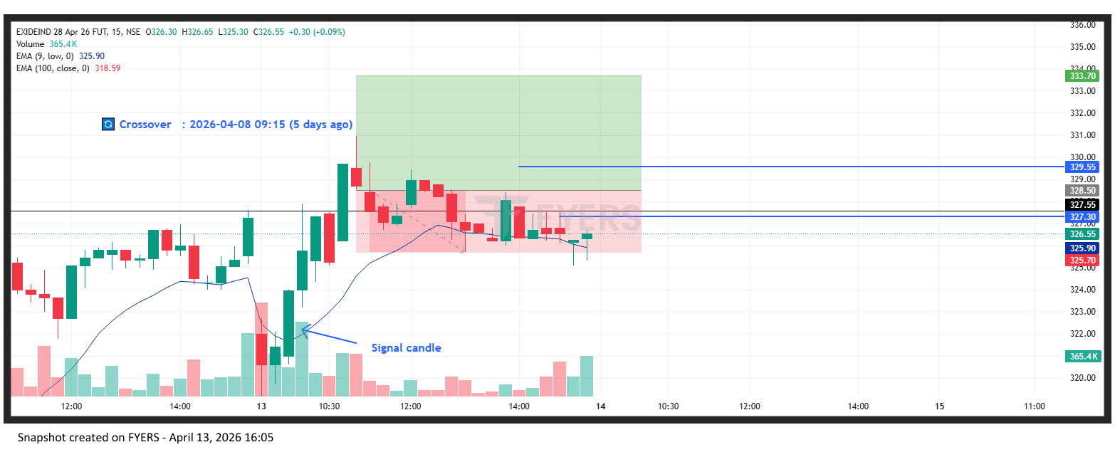
🟢 BULLISH SIGNAL --- TORNTPHARM26AprFUT

Nifty Bias : 🔴 SHORT — Counter Trend ⚠️
Crossover : 2026-04-09 11:00 (4 days ago)
Pullback : 2026-04-13 09:30
Low ₹4128.8 ≤ EMA9(Low) ₹4133.9
High ₹4169.5 (breakout level)
Confirm : 2026-04-13 09:45 (+1 candle)
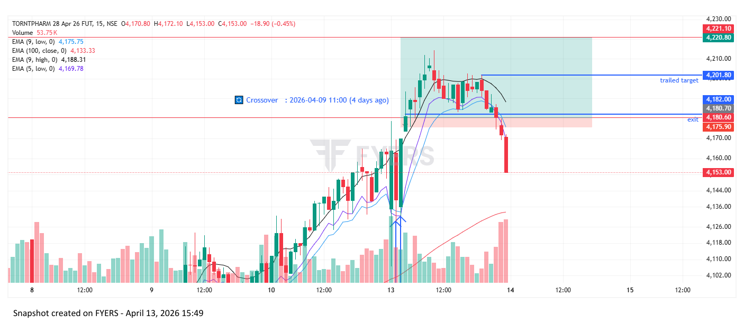
🟢 BULLISH SIGNAL --- SONACOMS26AprFUT

Nifty Bias : 🔴 SHORT — Counter Trend ⚠️
Crossover : 2026-04-06 09:45 (7 days ago)
Pullback : 2026-04-13 09:15
Low ₹543 ≤ EMA9(Low) ₹551.71
High ₹556.75 (breakout level)
Confirm : 2026-04-13 10:00 (+3 candle)
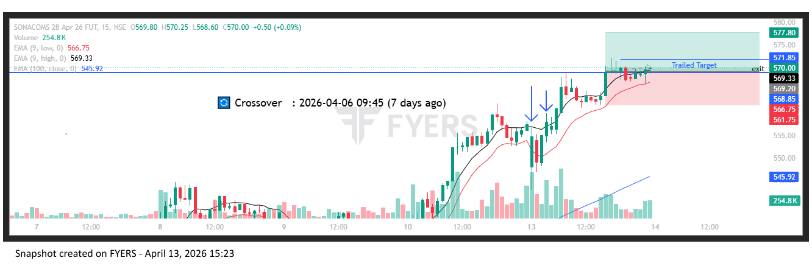
🟢 BULLISH SIGNAL --- MCX26AprFUT

Nifty Bias : 🔴 SHORT — Counter Trend ⚠️
Crossover : 2026-04-06 09:30 (7 days ago)
Pullback : 2026-04-13 09:30
Low ₹2658 ≤ EMA9(Low) ₹2664.92
High ₹2685.3 (breakout level)
Confirm : 2026-04-13 09:45 (+1 candle)
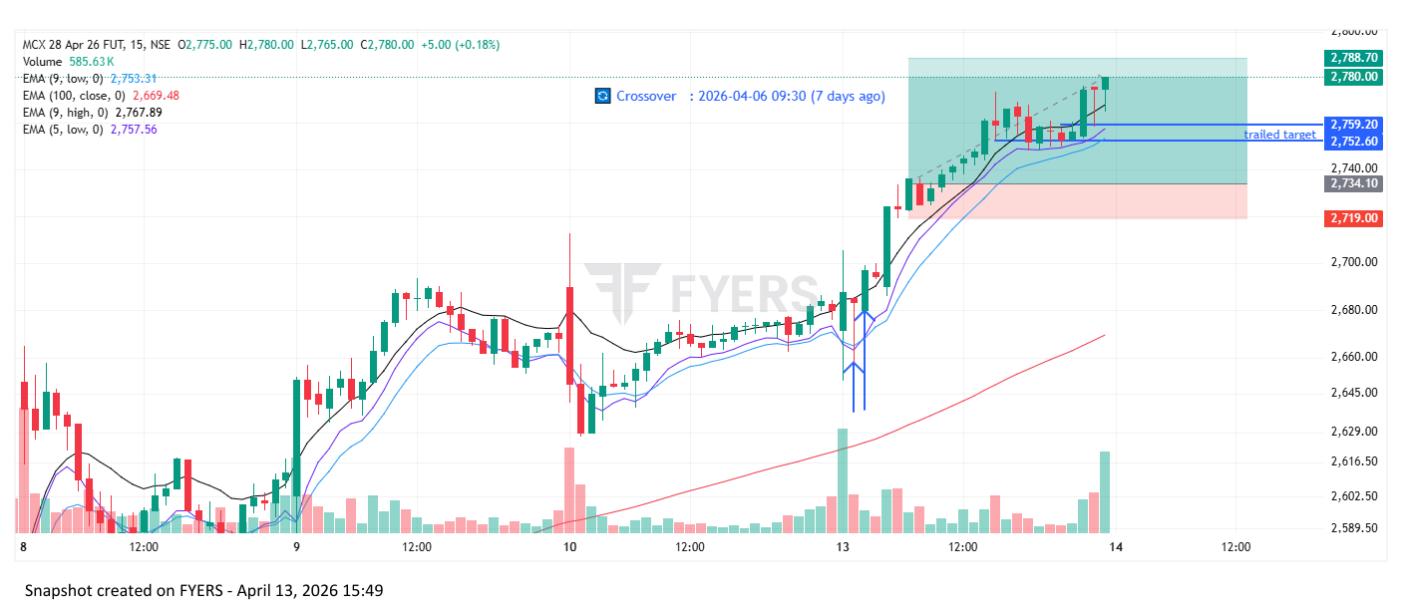
🟢 BULLISH SIGNAL --- OBEROIRLTY26AprFUT

Nifty Bias : 🔴 SHORT — Counter Trend ⚠️
Crossover : 2026-04-02 12:15 (11 days ago)
Pullback : 2026-04-13 09:30
Low ₹1613.1 ≤ EMA9(Low) ₹1624.17
High ₹1630 (breakout level)
Confirm : 2026-04-13 10:15 (+3 candle)
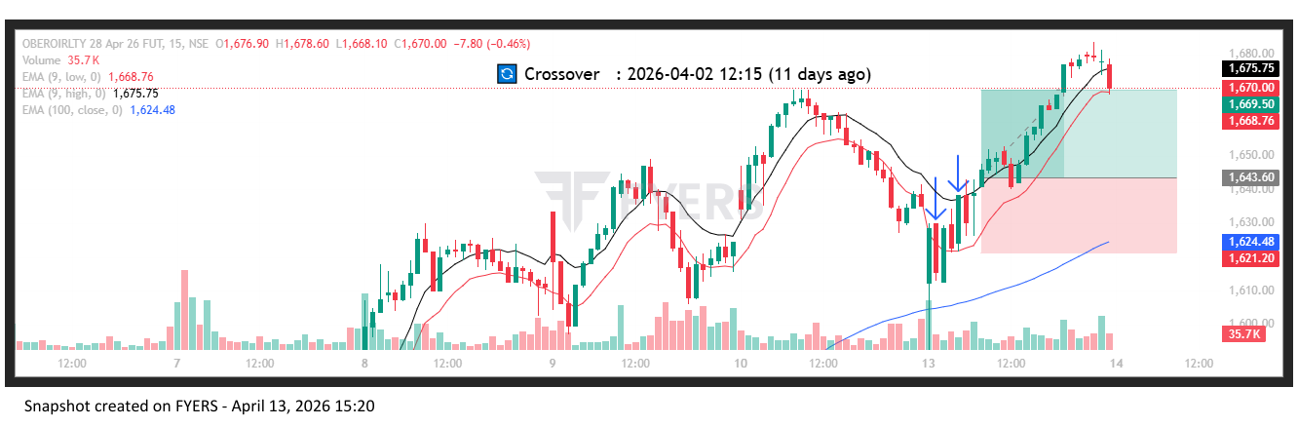
🟢 BULLISH SIGNAL --- VEDL26AprFUT

Nifty Bias : 🔴 SHORT — Counter Trend ⚠️
Crossover : 2026-04-02 13:30 (11 days ago)
Pullback : 2026-04-13 10:00
Low ₹740.6 ≤ EMA9(Low) ₹740.95
High ₹744.15 (breakout level)
Confirm : 2026-04-13 10:15 (+1 candle)
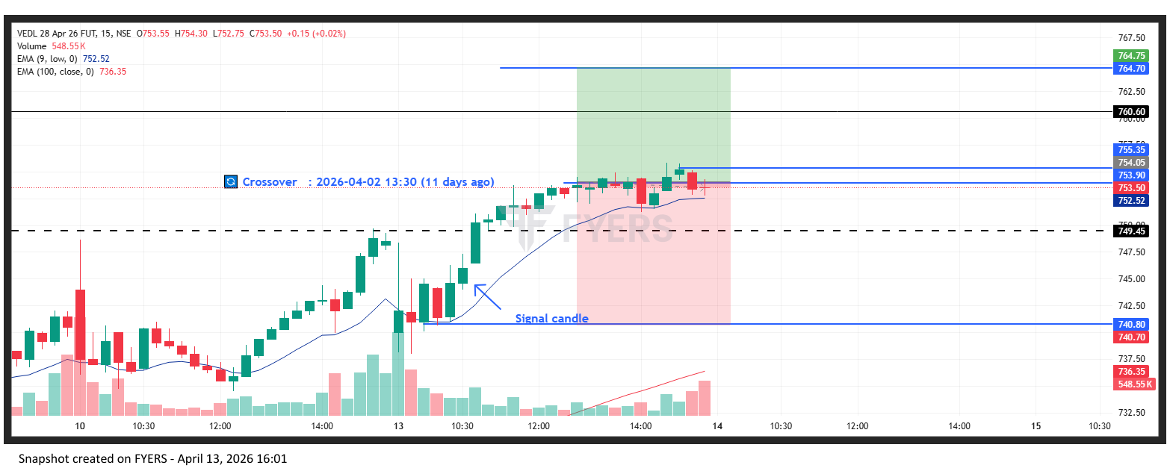
🟢 BULLISH SIGNAL --- POWERINDIA26AprFUT

Nifty Bias : 🔴 SHORT — Counter Trend ⚠️
Crossover : 2026-04-08 09:15 (5 days ago)
Pullback : 2026-04-13 10:30
Low ₹28145 ≤ EMA9(Low) ₹28147.44
High ₹28400 (breakout level)
Confirm : 2026-04-13 11:15 (+3 candle)
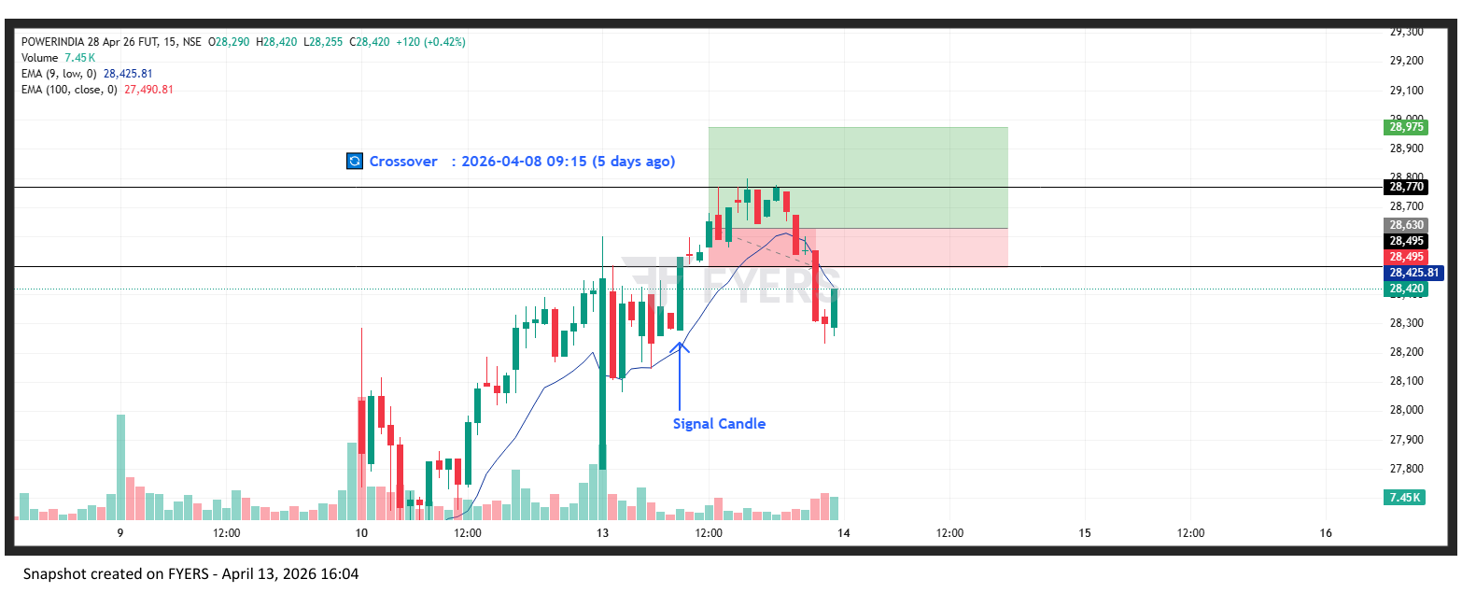

Trade Not Taken
🔴 BEARISH SIGNAL --- COFORGE26AprFUT

Nifty Bias : 🟢 LONG — Counter Trend ⚠️
Crossover : 2026-04-10 11:15 (3 days ago)
Pullback : 2026-04-10 14:45
High ₹1229 ≥ EMA9(High) ₹1228
Low ₹1223.8 (breakdown level)
Confirm : 2026-04-13 09:15 (+3 candle)
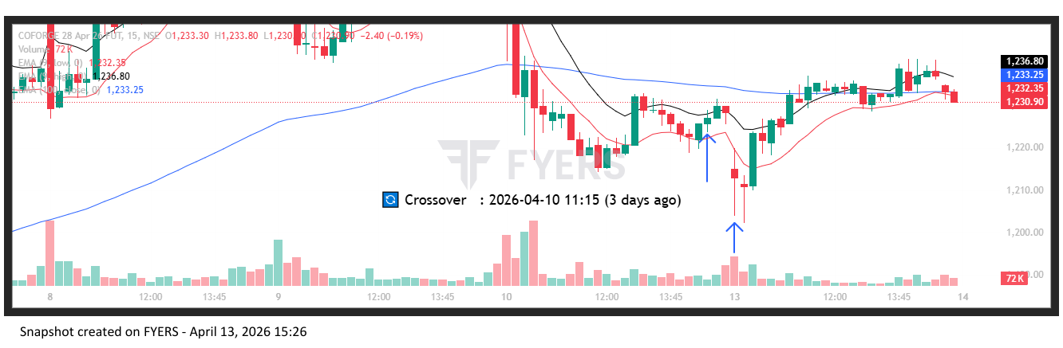
🔴 BEARISH SIGNAL --- INFY26AprFUT

Nifty Bias : 🟢 LONG — Counter Trend ⚠️
Crossover : 2026-04-10 09:45 (3 days ago)
Pullback : 2026-04-10 14:45
High ₹1294.8 ≥ EMA9(High) ₹1292.76
Low ₹1290.9 (breakdown level)
Confirm : 2026-04-13 09:15 (+3 candle)
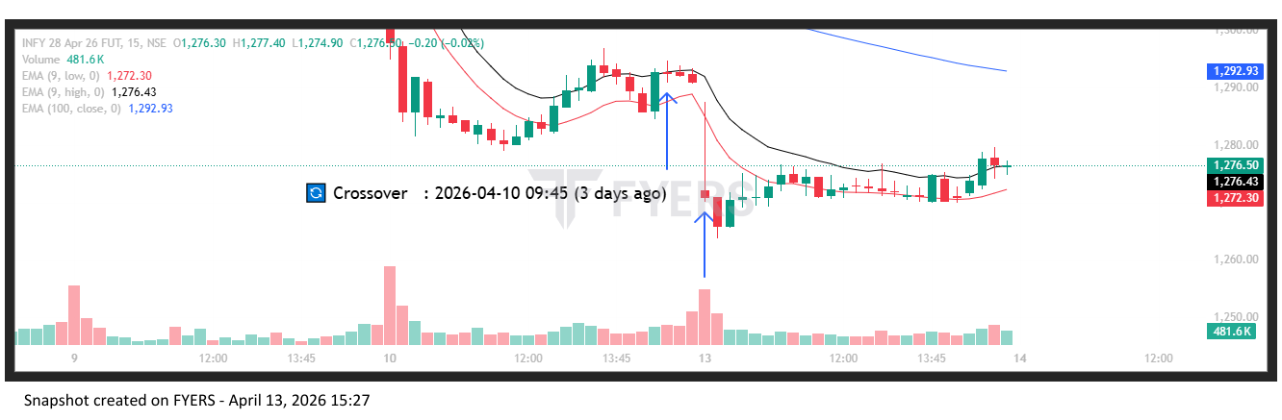
🟢 BULLISH SIGNAL --- OIL26AprFUT

Nifty Bias : 🟢 LONG — Aligned ✅
Crossover : 2026-04-10 11:30 (3 days ago)
Pullback : 2026-04-10 15:15
Low ₹471.1 ≤ EMA9(Low) ₹471.84
High ₹472.75 (breakout level)
Confirm : 2026-04-13 09:15 (+1 candle)
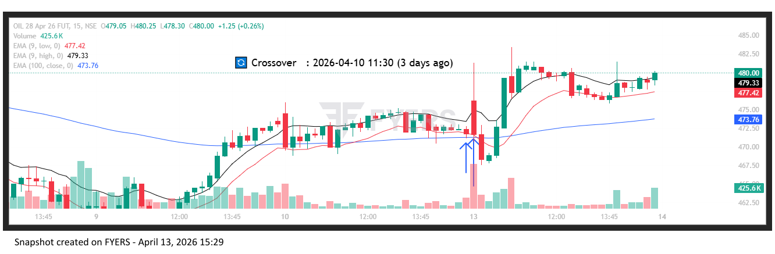
🔴 BEARISH SIGNAL --- SUNPHARMA26AprFUT

Nifty Bias : 🟢 LONG — Counter Trend ⚠️
Crossover : 2026-04-10 09:30 (3 days ago)
Pullback : 2026-04-10 15:00
High ₹1661.6 ≥ EMA9(High) ₹1657.93
Low ₹1659 (breakdown level)
Confirm : 2026-04-13 09:15 (+2 candle)
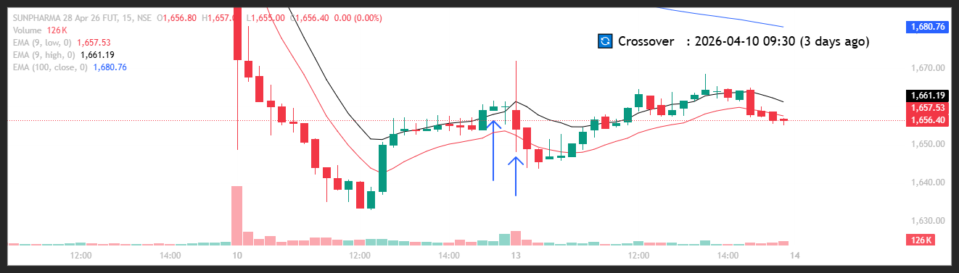
🔴 BEARISH SIGNAL --- TCS26AprFUT

Nifty Bias : 🟢 LONG — Counter Trend ⚠️
Crossover : 2026-04-10 10:45 (3 days ago)
Pullback : 2026-04-10 15:00
High ₹2515 ≥ EMA9(High) ₹2510.88
Low ₹2506.8 (breakdown level)
Confirm : 2026-04-13 09:15 (+2 candle)
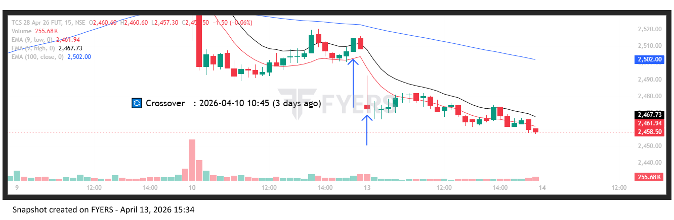
🔴 BEARISH SIGNAL --- TECHM26AprFUT

Nifty Bias : 🟢 LONG — Counter Trend ⚠️
Crossover : 2026-04-10 10:30 (3 days ago)
Pullback : 2026-04-10 14:45
High ₹1443.6 ≥ EMA9(High) ₹1443.33
Low ₹1440.1 (breakdown level)
Confirm : 2026-04-13 09:15 (+3 candle)
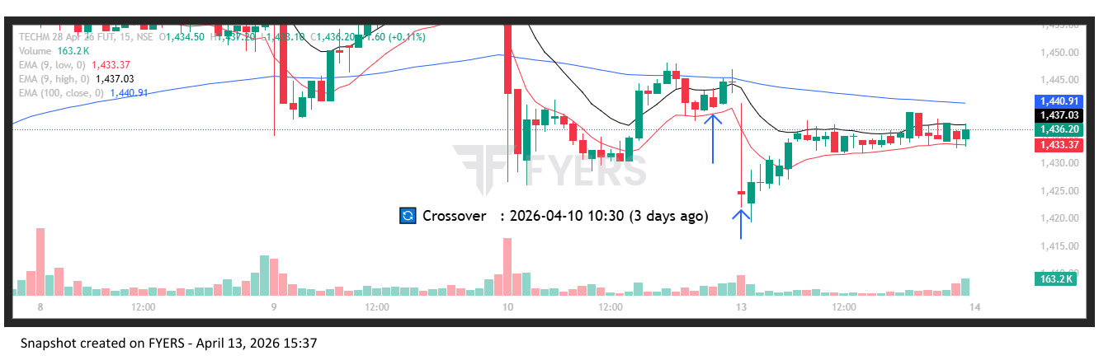
🟢 BULLISH SIGNAL --- ADANIGREEN26AprFUT

Nifty Bias : 🔴 SHORT — Counter Trend ⚠️
Crossover : 2026-04-02 15:15 (11 days ago)
Pullback : 2026-04-13 09:15
Low ₹1046.25 ≤ EMA9(Low) ₹1073.21
High ₹1073.95 (breakout level)
Confirm : 2026-04-13 09:30 (+1 candle)
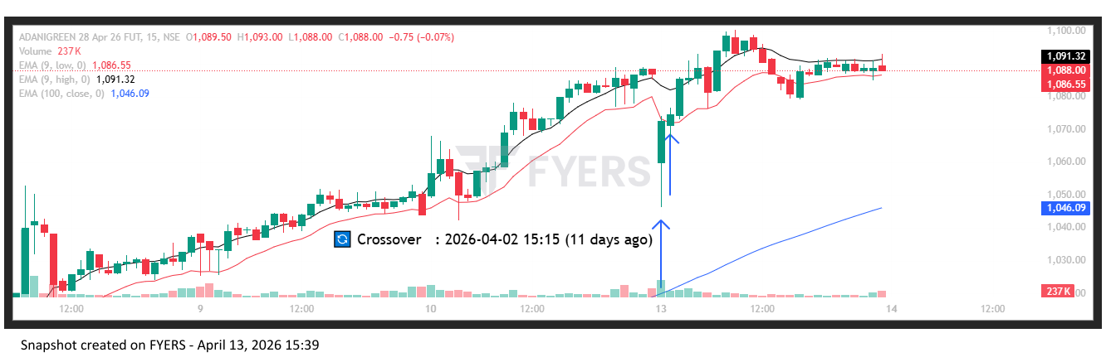
🟢 BULLISH SIGNAL --- APOLLOHOSP26AprFUT

Nifty Bias : 🔴 SHORT — Counter Trend ⚠️
Crossover : 2026-04-08 14:45 (5 days ago)
Pullback : 2026-04-13 09:15
Low ₹7417 ≤ EMA9(Low) ₹7504.98
High ₹7488 (breakout level)
Confirm : 2026-04-13 09:30 (+1 candle)
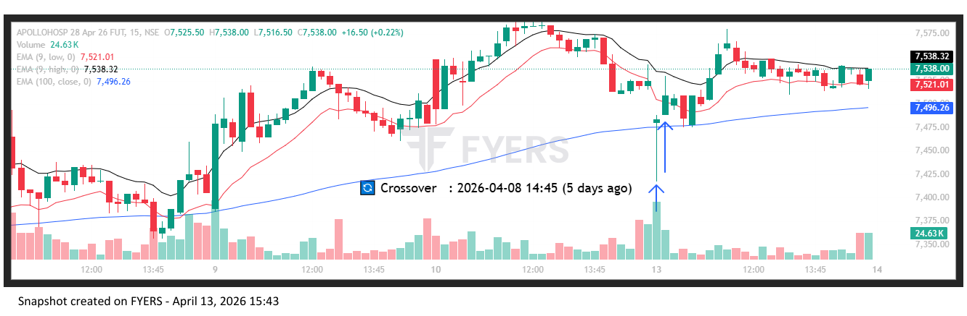
🟢 BULLISH SIGNAL --- ASIANPAINT26AprFUT

Nifty Bias : 🔴 SHORT — Counter Trend ⚠️
Crossover : 2026-04-08 09:15 (5 days ago)
Pullback : 2026-04-13 09:15
Low ₹2271.1 ≤ EMA9(Low) ₹2348.46
High ₹2313.4 (breakout level)
Confirm : 2026-04-13 09:30 (+1 candle)
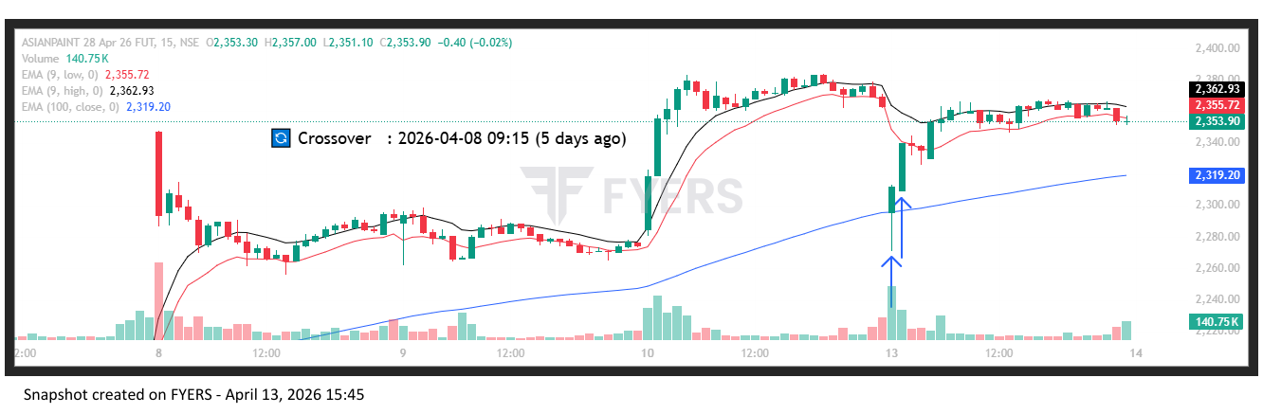
🟢 BULLISH SIGNAL --- AXISBANK26AprFUT

Nifty Bias : 🔴 SHORT — Counter Trend ⚠️
Crossover : 2026-04-06 09:15 (7 days ago)
Pullback : 2026-04-13 09:15
Low ₹1320.4 ≤ EMA9(Low) ₹1343.1
High ₹1333 (breakout level)
Confirm : 2026-04-13 09:30 (+1 candle)
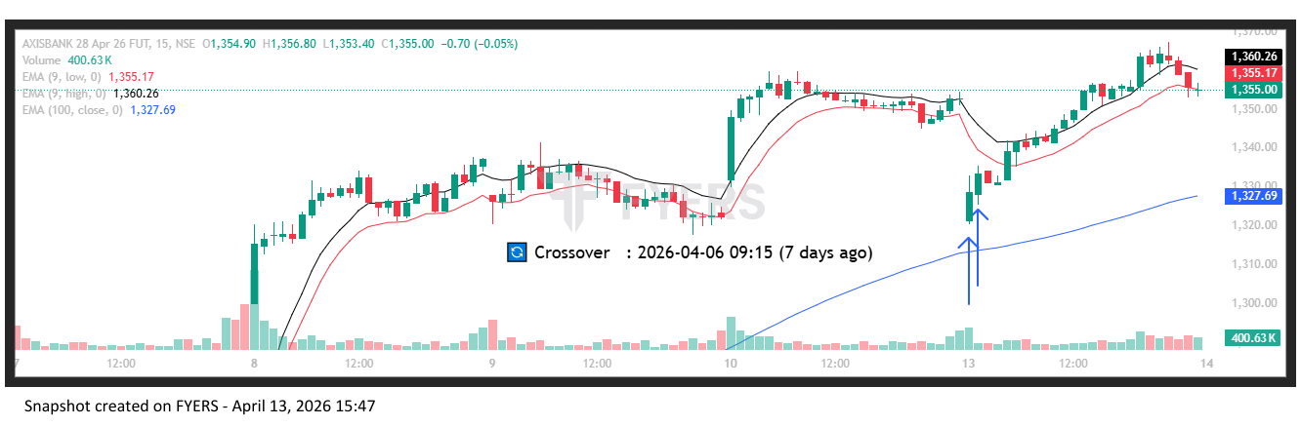
🟢 BULLISH SIGNAL --- BAJFINANCE26AprFUT

Nifty Bias : 🔴 SHORT — Counter Trend ⚠️
Crossover : 2026-04-06 12:30 (7 days ago)
Pullback : 2026-04-13 09:15
Low ₹883.85 ≤ EMA9(Low) ₹911.71
High ₹902 (breakout level)
Confirm : 2026-04-13 09:30 (+1 candle)
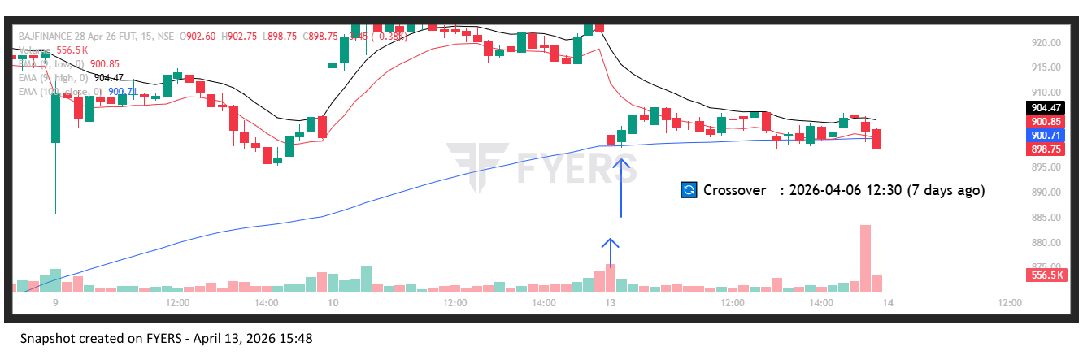
🟢 BULLISH SIGNAL --- BHARTIARTL26AprFUT

Nifty Bias : 🔴 SHORT — Counter Trend ⚠️
Crossover : 2026-04-07 10:00 (6 days ago)
Pullback : 2026-04-13 09:15
Low ₹1845.5 ≤ EMA9(Low) ₹1865.44
High ₹1856.9 (breakout level)
Confirm : 2026-04-13 09:30 (+1 candle)
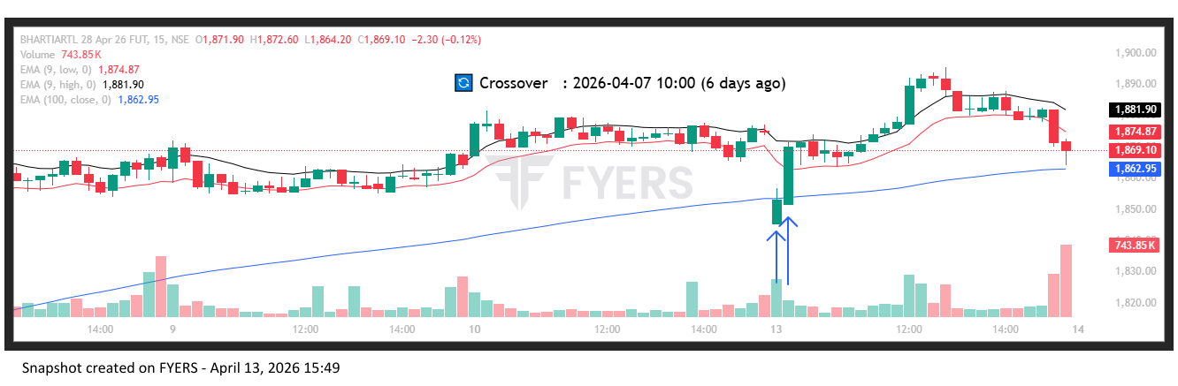
🟢 BULLISH SIGNAL --- BOSCHLTD26AprFUT

Nifty Bias : 🔴 SHORT — Counter Trend ⚠️
Crossover : 2026-04-01 10:30 (12 days ago)
Pullback : 2026-04-13 09:15
Low ₹36620 ≤ EMA9(Low) ₹37263.82
High ₹37145 (breakout level)
Confirm : 2026-04-13 09:30 (+1 candle)
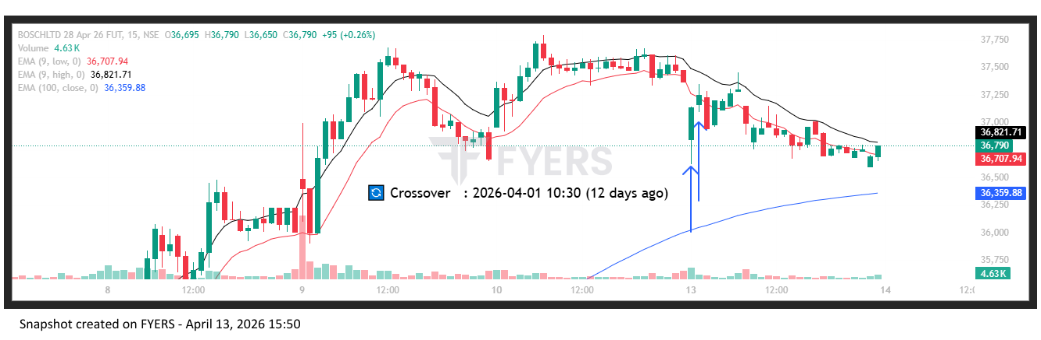
🟢 BULLISH SIGNAL --- DLF26AprFUT

Nifty Bias : 🔴 SHORT — Counter Trend ⚠️
Crossover : 2026-04-06 09:45 (7 days ago)
Pullback : 2026-04-13 09:15
Low ₹547.1 ≤ EMA9(Low) ₹564.59
High ₹559.7 (breakout level)
Confirm : 2026-04-13 09:30 (+1 candle)
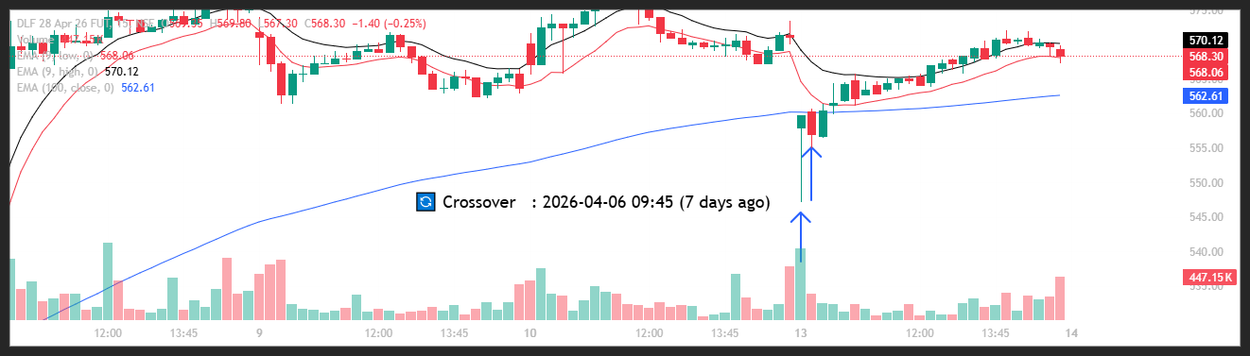
🟢 BULLISH SIGNAL --- DIXON26AprFUT

Nifty Bias : 🔴 SHORT — Counter Trend ⚠️
Crossover : 2026-04-07 12:00 (6 days ago)
Pullback : 2026-04-13 09:15
Low ₹10275 ≤ EMA9(Low) ₹10577.02
High ₹10425 (breakout level)
Confirm : 2026-04-13 09:30 (+1 candle)
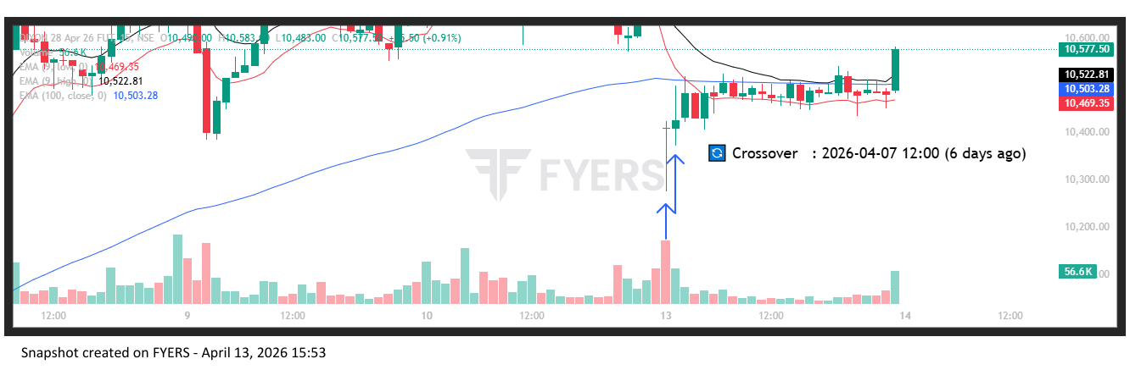
🟢 BULLISH SIGNAL --- GAIL26AprFUT

Nifty Bias : 🔴 SHORT — Counter Trend ⚠️
Crossover : 2026-04-02 14:15 (11 days ago)
Pullback : 2026-04-13 09:15
Low ₹149.75 ≤ EMA9(Low) ₹152.61
High ₹151.99 (breakout level)
Confirm : 2026-04-13 09:30 (+1 candle)
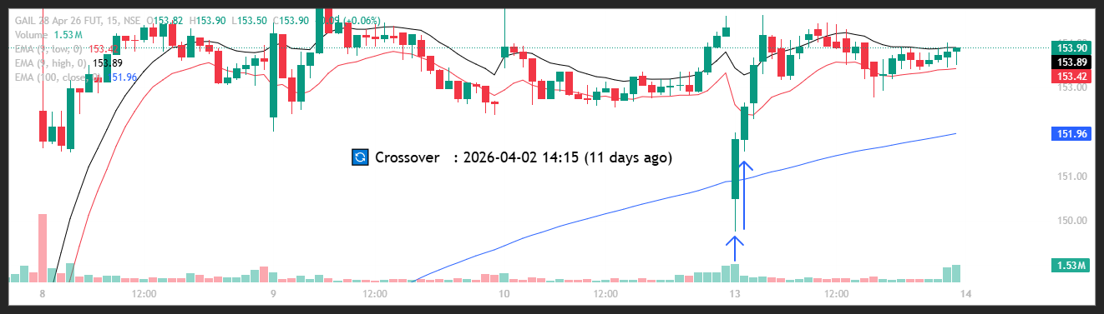
🟢 BULLISH SIGNAL --- ICICIBANK26AprFUT

Nifty Bias : 🔴 SHORT — Counter Trend ⚠️
Crossover : 2026-04-06 13:45 (7 days ago)
Pullback : 2026-04-13 09:15
Low ₹1298.7 ≤ EMA9(Low) ₹1314.82
High ₹1307.4 (breakout level)
Confirm : 2026-04-13 09:30 (+1 candle)
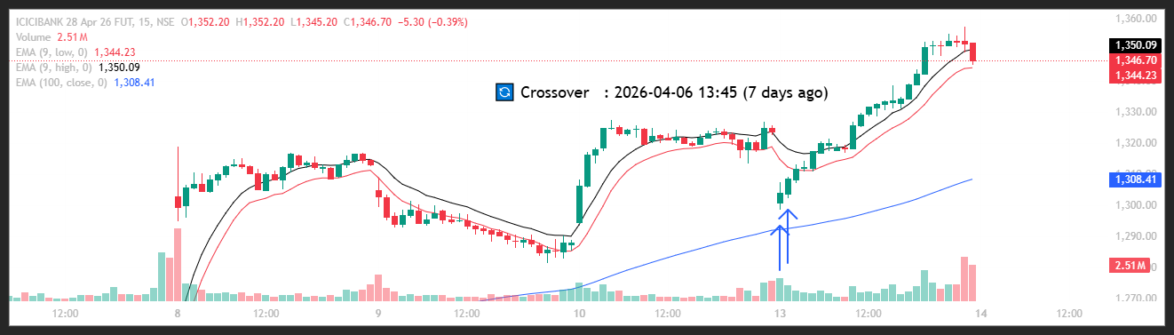
🟢 BULLISH SIGNAL --- INOXWIND26AprFUT

Nifty Bias : 🔴 SHORT — Counter Trend ⚠️
Crossover : 2026-04-06 11:15 (7 days ago)
Pullback : 2026-04-13 09:15
Low ₹82.79 ≤ EMA9(Low) ₹85.98
High ₹85.04 (breakout level)
Confirm : 2026-04-13 09:30 (+1 candle)

🟢 BULLISH SIGNAL --- LT26AprFUT

Nifty Bias : 🔴 SHORT — Counter Trend ⚠️
Crossover : 2026-04-02 14:45 (11 days ago)
Pullback : 2026-04-13 09:15
Low ₹3815 ≤ EMA9(Low) ₹3924.08
High ₹3910 (breakout level)
Confirm : 2026-04-13 09:30 (+1 candle)

🟢 BULLISH SIGNAL --- MUTHOOTFIN26AprFUT

Nifty Bias : 🔴 SHORT — Counter Trend ⚠️
Crossover : 2026-04-06 13:15 (7 days ago)
Pullback : 2026-04-13 09:15
Low ₹3423.6 ≤ EMA9(Low) ₹3502.99
High ₹3515.1 (breakout level)
Confirm : 2026-04-13 09:30 (+1 candle)

🟢 BULLISH SIGNAL --- PIDILITIND26AprFUT

Nifty Bias : 🔴 SHORT — Counter Trend ⚠️
Crossover : 2026-04-08 09:15 (5 days ago)
Pullback : 2026-04-13 09:15
Low ₹1318 ≤ EMA9(Low) ₹1348.47
High ₹1337.9 (breakout level)
Confirm : 2026-04-13 09:30 (+1 candle)

🟢 BULLISH SIGNAL --- SBICARD26AprFUT

Nifty Bias : 🔴 SHORT — Counter Trend ⚠️
Crossover : 2026-04-07 15:00 (6 days ago)
Pullback : 2026-04-13 09:15
Low ₹649.7 ≤ EMA9(Low) ₹668.35
High ₹662.65 (breakout level)
Confirm : 2026-04-13 09:30 (+1 candle)

🟢 BULLISH SIGNAL --- SAMMAANCAP26AprFUT

Nifty Bias : 🔴 SHORT — Counter Trend ⚠️
Crossover : 2026-04-08 10:15 (5 days ago)
Pullback : 2026-04-13 09:15
Low ₹152 ≤ EMA9(Low) ₹154.76
High ₹153.5 (breakout level)
Confirm : 2026-04-13 09:30 (+1 candle)

🟢 BULLISH SIGNAL --- SUZLON26AprFUT

Nifty Bias : 🔴 SHORT — Counter Trend ⚠️
Crossover : 2026-04-06 12:00 (7 days ago)
Pullback : 2026-04-13 09:15
Low ₹44.16 ≤ EMA9(Low) ₹44.95
High ₹44.79 (breakout level)
Confirm : 2026-04-13 09:30 (+1 candle)

🟢 BULLISH SIGNAL --- PHOENIXLTD26AprFUT

Nifty Bias : 🔴 SHORT — Counter Trend ⚠️
Crossover : 2026-04-06 10:15 (7 days ago)
Pullback : 2026-04-13 09:15
Low ₹1712.1 ≤ EMA9(Low) ₹1747.81
High ₹1746.7 (breakout level)
Confirm : 2026-04-13 09:30 (+1 candle)

🟢 BULLISH SIGNAL --- TORNTPOWER26AprFUT

Nifty Bias : 🔴 SHORT — Counter Trend ⚠️
Crossover : 2026-04-06 10:15 (7 days ago)
Pullback : 2026-04-13 09:15
Low ₹1440.1 ≤ EMA9(Low) ₹1458.49
High ₹1457.9 (breakout level)
Confirm : 2026-04-13 09:30 (+1 candle)

🟢 BULLISH SIGNAL --- UNITDSPR26AprFUT

Nifty Bias : 🔴 SHORT — Counter Trend ⚠️
Crossover : 2026-04-09 11:30 (4 days ago)
Pullback : 2026-04-13 09:15
Low ₹1238.1 ≤ EMA9(Low) ₹1261.04
High ₹1254.9 (breakout level)
Confirm : 2026-04-13 09:30 (+1 candle)

🟢 BULLISH SIGNAL --- IDEA26AprFUT

Nifty Bias : 🔴 SHORT — Counter Trend ⚠️
Crossover : 2026-04-08 09:15 (5 days ago)
Pullback : 2026-04-13 09:15
Low ₹8.97 ≤ EMA9(Low) ₹9.19
High ₹9.11 (breakout level)
Confirm : 2026-04-13 09:30 (+1 candle)

🟢 BULLISH SIGNAL --- AUBANK26AprFUT

Nifty Bias : 🔴 SHORT — Counter Trend ⚠️
Crossover : 2026-04-06 12:45 (7 days ago)
Pullback : 2026-04-13 09:30
Low ₹960 ≤ EMA9(Low) ₹971.15
High ₹966.65 (breakout level)
Confirm : 2026-04-13 09:45 (+1 candle)

🟢 BULLISH SIGNAL --- ADANIPORTS26AprFUT

Nifty Bias : 🔴 SHORT — Counter Trend ⚠️
Crossover : 2026-04-06 13:00 (7 days ago)
Pullback : 2026-04-13 09:15
Low ₹1426.3 ≤ EMA9(Low) ₹1464.81
High ₹1454.3 (breakout level)
Confirm : 2026-04-13 09:45 (+2 candle)

🟢 BULLISH SIGNAL --- ABCAPITAL26AprFUT

Nifty Bias : 🔴 SHORT — Counter Trend ⚠️
Crossover : 2026-04-06 10:45 (7 days ago)
Pullback : 2026-04-13 09:30
Low ₹330.5 ≤ EMA9(Low) ₹336.67
High ₹333.55 (breakout level)
Confirm : 2026-04-13 09:45 (+1 candle)

🟢 BULLISH SIGNAL --- ALKEM26AprFUT

Nifty Bias : 🔴 SHORT — Counter Trend ⚠️
Crossover : 2026-04-09 10:45 (4 days ago)
Pullback : 2026-04-13 09:30
Low ₹5340 ≤ EMA9(Low) ₹5386.59
High ₹5381.5 (breakout level)
Confirm : 2026-04-13 09:45 (+1 candle)

🟢 BULLISH SIGNAL --- AMBUJACEM26AprFUT

Nifty Bias : 🔴 SHORT — Counter Trend ⚠️
Crossover : 2026-04-02 15:00 (11 days ago)
Pullback : 2026-04-13 09:15
Low ₹428.15 ≤ EMA9(Low) ₹440.7
High ₹435.55 (breakout level)
Confirm : 2026-04-13 09:45 (+2 candle)

🟢 BULLISH SIGNAL --- ASTRAL26AprFUT

Nifty Bias : 🔴 SHORT — Counter Trend ⚠️
Crossover : 2026-04-09 11:15 (4 days ago)
Pullback : 2026-04-13 09:15
Low ₹1562.1 ≤ EMA9(Low) ₹1589.09
High ₹1597 (breakout level)
Confirm : 2026-04-13 09:45 (+2 candle)

🟢 BULLISH SIGNAL --- AUROPHARMA26AprFUT

Nifty Bias : 🔴 SHORT — Counter Trend ⚠️
Crossover : 2026-04-09 12:15 (4 days ago)
Pullback : 2026-04-13 09:30
Low ₹1337.4 ≤ EMA9(Low) ₹1346.66
High ₹1346.8 (breakout level)
Confirm : 2026-04-13 09:45 (+1 candle)

🟢 BULLISH SIGNAL --- BAJAJ-AUTO26AprFUT

Nifty Bias : 🔴 SHORT — Counter Trend ⚠️
Crossover : 2026-04-06 11:15 (7 days ago)
Pullback : 2026-04-13 09:15
Low ₹9712 ≤ EMA9(Low) ₹9768.12
High ₹9785.5 (breakout level)
Confirm : 2026-04-13 09:45 (+2 candle)

🟢 BULLISH SIGNAL --- CANBK26AprFUT

Nifty Bias : 🔴 SHORT — Counter Trend ⚠️
Crossover : 2026-04-06 12:00 (7 days ago)
Pullback : 2026-04-13 09:15
Low ₹135.01 ≤ EMA9(Low) ₹139.12
High ₹136.79 (breakout level)
Confirm : 2026-04-13 09:45 (+2 candle)

🟢 BULLISH SIGNAL --- CDSL26AprFUT

Nifty Bias : 🔴 SHORT — Counter Trend ⚠️
Crossover : 2026-04-06 10:15 (7 days ago)
Pullback : 2026-04-13 09:15
Low ₹1254 ≤ EMA9(Low) ₹1290.75
High ₹1277 (breakout level)
Confirm : 2026-04-13 09:45 (+2 candle)

🟢 BULLISH SIGNAL --- COLPAL26AprFUT

Nifty Bias : 🔴 SHORT — Counter Trend ⚠️
Crossover : 2026-04-07 12:30 (6 days ago)
Pullback : 2026-04-13 09:30
Low ₹1896.6 ≤ EMA9(Low) ₹1919.27
High ₹1908.7 (breakout level)
Confirm : 2026-04-13 09:45 (+1 candle)

🟢 BULLISH SIGNAL --- CONCOR26AprFUT

Nifty Bias : 🔴 SHORT — Counter Trend ⚠️
Crossover : 2026-04-06 10:15 (7 days ago)
Pullback : 2026-04-13 09:15
Low ₹469.15 ≤ EMA9(Low) ₹479.82
High ₹477 (breakout level)
Confirm : 2026-04-13 09:45 (+2 candle)

🟢 BULLISH SIGNAL --- DALBHARAT26AprFUT

Nifty Bias : 🔴 SHORT — Counter Trend ⚠️
Crossover : 2026-04-06 10:15 (7 days ago)
Pullback : 2026-04-13 09:30
Low ₹1912.2 ≤ EMA9(Low) ₹1937.96
High ₹1925 (breakout level)
Confirm : 2026-04-13 09:45 (+1 candle)

🟢 BULLISH SIGNAL --- DELHIVERY26AprFUT

Nifty Bias : 🔴 SHORT — Counter Trend ⚠️
Crossover : 2026-04-06 10:45 (7 days ago)
Pullback : 2026-04-13 09:15
Low ₹456.6 ≤ EMA9(Low) ₹468.23
High ₹468.3 (breakout level)
Confirm : 2026-04-13 09:45 (+2 candle)

🟢 BULLISH SIGNAL --- DRREDDY26AprFUT

Nifty Bias : 🔴 SHORT — Counter Trend ⚠️
Crossover : 2026-04-09 11:45 (4 days ago)
Pullback : 2026-04-13 09:30
Low ₹1203.5 ≤ EMA9(Low) ₹1222
High ₹1213.9 (breakout level)
Confirm : 2026-04-13 09:45 (+1 candle)

🟢 BULLISH SIGNAL --- NYKAA26AprFUT

Nifty Bias : 🔴 SHORT — Counter Trend ⚠️
Crossover : 2026-04-02 14:00 (11 days ago)
Pullback : 2026-04-13 09:30
Low ₹255.7 ≤ EMA9(Low) ₹257.23
High ₹257.71 (breakout level)
Confirm : 2026-04-13 09:45 (+1 candle)

🟢 BULLISH SIGNAL --- HEROMOTOCO26AprFUT

Nifty Bias : 🔴 SHORT — Counter Trend ⚠️
Crossover : 2026-04-08 09:15 (5 days ago)
Pullback : 2026-04-13 09:15
Low ₹5313.5 ≤ EMA9(Low) ₹5437.09
High ₹5380 (breakout level)
Confirm : 2026-04-13 09:45 (+2 candle)

🟢 BULLISH SIGNAL --- ICICIGI26AprFUT

Nifty Bias : 🔴 SHORT — Counter Trend ⚠️
Crossover : 2026-04-07 12:15 (6 days ago)
Pullback : 2026-04-13 09:15
Low ₹1755.3 ≤ EMA9(Low) ₹1779.84
High ₹1775.2 (breakout level)
Confirm : 2026-04-13 09:45 (+2 candle)

🟢 BULLISH SIGNAL --- PFC26AprFUT

Nifty Bias : 🔴 SHORT — Counter Trend ⚠️
Crossover : 2026-04-02 14:15 (11 days ago)
Pullback : 2026-04-13 09:30
Low ₹424 ≤ EMA9(Low) ₹429.31
High ₹427.2 (breakout level)
Confirm : 2026-04-13 09:45 (+1 candle)

🟢 BULLISH SIGNAL --- POWERGRID26AprFUT

Nifty Bias : 🔴 SHORT — Counter Trend ⚠️
Crossover : 2026-04-06 14:45 (7 days ago)
Pullback : 2026-04-13 09:30
Low ₹300.35 ≤ EMA9(Low) ₹301.25
High ₹301.8 (breakout level)
Confirm : 2026-04-13 09:45 (+1 candle)

🟢 BULLISH SIGNAL --- PRESTIGE26AprFUT

Nifty Bias : 🔴 SHORT — Counter Trend ⚠️
Crossover : 2026-04-06 12:30 (7 days ago)
Pullback : 2026-04-13 09:15
Low ₹1267 ≤ EMA9(Low) ₹1313.61
High ₹1301 (breakout level)
Confirm : 2026-04-13 09:45 (+2 candle)

🟢 BULLISH SIGNAL --- PNB26AprFUT

Nifty Bias : 🔴 SHORT — Counter Trend ⚠️
Crossover : 2026-04-08 09:15 (5 days ago)
Pullback : 2026-04-13 09:30
Low ₹108.12 ≤ EMA9(Low) ₹110.3
High ₹108.72 (breakout level)
Confirm : 2026-04-13 09:45 (+1 candle)

🟢 BULLISH SIGNAL --- SBILIFE26AprFUT

Nifty Bias : 🔴 SHORT — Counter Trend ⚠️
Crossover : 2026-04-06 13:00 (7 days ago)
Pullback : 2026-04-13 09:30
Low ₹1896 ≤ EMA9(Low) ₹1916.28
High ₹1909.1 (breakout level)
Confirm : 2026-04-13 09:45 (+1 candle)

🟢 BULLISH SIGNAL --- SHREECEM26AprFUT

Nifty Bias : 🔴 SHORT — Counter Trend ⚠️
Crossover : 2026-04-06 13:15 (7 days ago)
Pullback : 2026-04-13 09:30
Low ₹23820 ≤ EMA9(Low) ₹24132
High ₹23925 (breakout level)
Confirm : 2026-04-13 09:45 (+1 candle)

🟢 BULLISH SIGNAL --- SHRIRAMFIN26AprFUT

Nifty Bias : 🔴 SHORT — Counter Trend ⚠️
Crossover : 2026-04-06 11:30 (7 days ago)
Pullback : 2026-04-13 09:30
Low ₹997.2 ≤ EMA9(Low) ₹1013.42
High ₹1003.55 (breakout level)
Confirm : 2026-04-13 09:45 (+1 candle)

🟢 BULLISH SIGNAL --- SAIL26AprFUT

Nifty Bias : 🔴 SHORT — Counter Trend ⚠️
Crossover : 2026-04-02 13:30 (11 days ago)
Pullback : 2026-04-13 09:30
Low ₹162.25 ≤ EMA9(Low) ₹164.46
High ₹163.71 (breakout level)
Confirm : 2026-04-13 09:45 (+1 candle)

🟢 BULLISH SIGNAL --- TATAELXSI26AprFUT

Nifty Bias : 🔴 SHORT — Counter Trend ⚠️
Crossover : 2026-04-02 12:45 (11 days ago)
Pullback : 2026-04-13 09:30
Low ₹4344.6 ≤ EMA9(Low) ₹4400.51
High ₹4376 (breakout level)
Confirm : 2026-04-13 09:45 (+1 candle)

🟢 BULLISH SIGNAL --- TMPV26AprFUT

Nifty Bias : 🔴 SHORT — Counter Trend ⚠️
Crossover : 2026-04-07 13:30 (6 days ago)
Pullback : 2026-04-13 09:15
Low ₹335.65 ≤ EMA9(Low) ₹339.85
High ₹339.4 (breakout level)
Confirm : 2026-04-13 09:45 (+2 candle)

🟢 BULLISH SIGNAL --- INDHOTEL26AprFUT

Nifty Bias : 🔴 SHORT — Counter Trend ⚠️
Crossover : 2026-04-07 10:30 (6 days ago)
Pullback : 2026-04-13 09:15
Low ₹619.95 ≤ EMA9(Low) ₹636.36
High ₹634.3 (breakout level)
Confirm : 2026-04-13 09:45 (+2 candle)

🟢 BULLISH SIGNAL --- TRENT26AprFUT

Nifty Bias : 🔴 SHORT — Counter Trend ⚠️
Crossover : 2026-04-02 12:45 (11 days ago)
Pullback : 2026-04-13 09:15
Low ₹3821.3 ≤ EMA9(Low) ₹3901.63
High ₹3874 (breakout level)
Confirm : 2026-04-13 09:45 (+2 candle)

🟢 BULLISH SIGNAL --- TIINDIA26AprFUT

Nifty Bias : 🔴 SHORT — Counter Trend ⚠️
Crossover : 2026-04-07 13:00 (6 days ago)
Pullback : 2026-04-13 09:30
Low ₹2685.8 ≤ EMA9(Low) ₹2718.84
High ₹2715.6 (breakout level)
Confirm : 2026-04-13 09:45 (+1 candle)

🟢 BULLISH SIGNAL --- UNIONBANK26AprFUT

Nifty Bias : 🔴 SHORT — Counter Trend ⚠️
Crossover : 2026-04-08 09:15 (5 days ago)
Pullback : 2026-04-13 09:30
Low ₹178.77 ≤ EMA9(Low) ₹184.26
High ₹180.34 (breakout level)
Confirm : 2026-04-13 09:45 (+1 candle)

🟢 BULLISH SIGNAL --- VBL26AprFUT

Nifty Bias : 🔴 SHORT — Counter Trend ⚠️
Crossover : 2026-04-07 12:45 (6 days ago)
Pullback : 2026-04-13 09:15
Low ₹418.1 ≤ EMA9(Low) ₹429.7
High ₹430.4 (breakout level)
Confirm : 2026-04-13 09:45 (+2 candle)

🟢 BULLISH SIGNAL --- YESBANK26AprFUT

Nifty Bias : 🔴 SHORT — Counter Trend ⚠️
Crossover : 2026-04-06 10:15 (7 days ago)
Pullback : 2026-04-13 09:30
Low ₹18.63 ≤ EMA9(Low) ₹18.94
High ₹18.71 (breakout level)
Confirm : 2026-04-13 09:45 (+1 candle)

🟢 BULLISH SIGNAL --- ABB26AprFUT

Nifty Bias : 🔴 SHORT — Counter Trend ⚠️
Crossover : 2026-04-02 14:15 (11 days ago)
Pullback : 2026-04-13 09:45
Low ₹6755 ≤ EMA9(Low) ₹6781.42
High ₹6817.5 (breakout level)
Confirm : 2026-04-13 10:00 (+1 candle)

🟢 BULLISH SIGNAL --- BSE26AprFUT

Nifty Bias : 🔴 SHORT — Counter Trend ⚠️
Crossover : 2026-04-02 14:00 (11 days ago)
Pullback : 2026-04-13 09:45
Low ₹3261.1 ≤ EMA9(Low) ₹3264.81
High ₹3278.9 (breakout level)
Confirm : 2026-04-13 10:00 (+1 candle)

🟢 BULLISH SIGNAL --- BDL26AprFUT

Nifty Bias : 🔴 SHORT — Counter Trend ⚠️
Crossover : 2026-04-01 10:15 (12 days ago)
Pullback : 2026-04-13 09:45
Low ₹1316.5 ≤ EMA9(Low) ₹1330.79
High ₹1322.4 (breakout level)
Confirm : 2026-04-13 10:00 (+1 candle)

🟢 BULLISH SIGNAL --- BEL26AprFUT

Nifty Bias : 🔴 SHORT — Counter Trend ⚠️
Crossover : 2026-04-02 13:30 (11 days ago)
Pullback : 2026-04-13 09:15
Low ₹436 ≤ EMA9(Low) ₹442.08
High ₹441.85 (breakout level)
Confirm : 2026-04-13 10:00 (+3 candle)

🟢 BULLISH SIGNAL --- CAMS26AprFUT

Nifty Bias : 🔴 SHORT — Counter Trend ⚠️
Crossover : 2026-04-02 14:15 (11 days ago)
Pullback : 2026-04-13 09:45
Low ₹697.5 ≤ EMA9(Low) ₹704.98
High ₹701.35 (breakout level)
Confirm : 2026-04-13 10:00 (+1 candle)

🟢 BULLISH SIGNAL --- DIVISLAB26AprFUT

Nifty Bias : 🔴 SHORT — Counter Trend ⚠️
Crossover : 2026-04-09 11:30 (4 days ago)
Pullback : 2026-04-13 09:15
Low ₹5988.5 ≤ EMA9(Low) ₹6083.18
High ₹6045 (breakout level)
Confirm : 2026-04-13 10:00 (+3 candle)

🟢 BULLISH SIGNAL --- GODREJPROP26AprFUT

Nifty Bias : 🔴 SHORT — Counter Trend ⚠️
Crossover : 2026-04-06 10:00 (7 days ago)
Pullback : 2026-04-13 09:45
Low ₹1669.6 ≤ EMA9(Low) ₹1691.75
High ₹1685.7 (breakout level)
Confirm : 2026-04-13 10:00 (+1 candle)

🟢 BULLISH SIGNAL --- HDFCAMC26AprFUT

Nifty Bias : 🔴 SHORT — Counter Trend ⚠️
Crossover : 2026-04-02 13:30 (11 days ago)
Pullback : 2026-04-13 09:45
Low ₹2556 ≤ EMA9(Low) ₹2582.28
High ₹2569.1 (breakout level)
Confirm : 2026-04-13 10:00 (+1 candle)

🟢 BULLISH SIGNAL --- HDFCBANK26AprFUT

Nifty Bias : 🔴 SHORT — Counter Trend ⚠️
Crossover : 2026-04-06 11:45 (7 days ago)
Pullback : 2026-04-13 09:30
Low ₹790.65 ≤ EMA9(Low) ₹803.49
High ₹794.15 (breakout level)
Confirm : 2026-04-13 10:00 (+2 candle)

🟢 BULLISH SIGNAL --- ICICIPRULI26AprFUT

Nifty Bias : 🔴 SHORT — Counter Trend ⚠️
Crossover : 2026-04-07 13:45 (6 days ago)
Pullback : 2026-04-13 09:30
Low ₹540.5 ≤ EMA9(Low) ₹541.86
High ₹544.35 (breakout level)
Confirm : 2026-04-13 09:45 (+1 candle)

🟢 BULLISH SIGNAL --- IDFCFIRSTB26AprFUT

Nifty Bias : 🔴 SHORT — Counter Trend ⚠️
Crossover : 2026-04-06 14:45 (7 days ago)
Pullback : 2026-04-13 09:30
Low ₹63.96 ≤ EMA9(Low) ₹65.32
High ₹64.39 (breakout level)
Confirm : 2026-04-13 09:45 (+1 candle)

🟢 BULLISH SIGNAL --- INDIANB26AprFUT

Nifty Bias : 🔴 SHORT — Counter Trend ⚠️
Crossover : 2026-04-06 09:30 (7 days ago)
Pullback : 2026-04-13 09:30
Low ₹935.05 ≤ EMA9(Low) ₹951.56
High ₹941 (breakout level)
Confirm : 2026-04-13 09:45 (+1 candle)

🟢 BULLISH SIGNAL --- IEX26AprFUT

Nifty Bias : 🔴 SHORT — Counter Trend ⚠️
Crossover : 2026-04-06 10:15 (7 days ago)
Pullback : 2026-04-13 09:15
Low ₹126.7 ≤ EMA9(Low) ₹129.54
High ₹128.76 (breakout level)
Confirm : 2026-04-13 10:00 (+3 candle)

🟢 BULLISH SIGNAL --- IRFC26AprFUT

Nifty Bias : 🔴 SHORT — Counter Trend ⚠️
Crossover : 2026-04-06 11:00 (7 days ago)
Pullback : 2026-04-13 09:15
Low ₹96.35 ≤ EMA9(Low) ₹99.06
High ₹97.79 (breakout level)
Confirm : 2026-04-13 09:45 (+2 candle)

🟢 BULLISH SIGNAL --- IREDA26AprFUT

Nifty Bias : 🔴 SHORT — Counter Trend ⚠️
Crossover : 2026-04-06 10:45 (7 days ago)
Pullback : 2026-04-13 09:15
Low ₹118.12 ≤ EMA9(Low) ₹122.18
High ₹120.45 (breakout level)
Confirm : 2026-04-13 09:45 (+2 candle)

🟢 BULLISH SIGNAL --- JSWSTEEL26AprFUT

Nifty Bias : 🔴 SHORT — Counter Trend ⚠️
Crossover : 2026-04-07 14:00 (6 days ago)
Pullback : 2026-04-13 09:30
Low ₹1194 ≤ EMA9(Low) ₹1206.85
High ₹1203.1 (breakout level)
Confirm : 2026-04-13 10:00 (+2 candle)

🟢 BULLISH SIGNAL --- JUBLFOOD26AprFUT

Nifty Bias : 🔴 SHORT — Counter Trend ⚠️
Crossover : 2026-04-10 11:00 (3 days ago)
Pullback : 2026-04-13 09:15
Low ₹426.45 ≤ EMA9(Low) ₹436.04
High ₹433.95 (breakout level)
Confirm : 2026-04-13 09:45 (+2 candle)

🟢 BULLISH SIGNAL --- KEI26AprFUT

Nifty Bias : 🔴 SHORT — Counter Trend ⚠️
Crossover : 2026-04-06 10:30 (7 days ago)
Pullback : 2026-04-13 09:45
Low ₹4337.9 ≤ EMA9(Low) ₹4393.32
High ₹4367 (breakout level)
Confirm : 2026-04-13 10:00 (+1 candle)

🟢 BULLISH SIGNAL --- KAYNES26AprFUT

Nifty Bias : 🔴 SHORT — Counter Trend ⚠️
Crossover : 2026-04-06 12:00 (7 days ago)
Pullback : 2026-04-13 09:15
Low ₹3725.6 ≤ EMA9(Low) ₹3815.71
High ₹3808.1 (breakout level)
Confirm : 2026-04-13 10:00 (+3 candle)

🟢 BULLISH SIGNAL --- LAURUSLABS26AprFUT

Nifty Bias : 🔴 SHORT — Counter Trend ⚠️
Crossover : 2026-04-02 12:30 (11 days ago)
Pullback : 2026-04-13 09:45
Low ₹1084 ≤ EMA9(Low) ₹1091.01
High ₹1088.9 (breakout level)
Confirm : 2026-04-13 10:00 (+1 candle)

🟢 BULLISH SIGNAL --- PIIND26AprFUT

Nifty Bias : 🔴 SHORT — Counter Trend ⚠️
Crossover : 2026-04-09 11:45 (4 days ago)
Pullback : 2026-04-13 09:30
Low ₹2896 ≤ EMA9(Low) ₹2923.06
High ₹2913.8 (breakout level)
Confirm : 2026-04-13 10:00 (+2 candle)

🟢 BULLISH SIGNAL --- PAGEIND26AprFUT

Nifty Bias : 🔴 SHORT — Counter Trend ⚠️
Crossover : 2026-04-01 10:15 (12 days ago)
Pullback : 2026-04-13 09:15
Low ₹35650 ≤ EMA9(Low) ₹36026.86
High ₹36100 (breakout level)
Confirm : 2026-04-13 09:45 (+2 candle)

🟢 BULLISH SIGNAL --- PPLPHARMA26AprFUT

Nifty Bias : 🔴 SHORT — Counter Trend ⚠️
Crossover : 2026-04-06 14:30 (7 days ago)
Pullback : 2026-04-13 09:15
Low ₹140.41 ≤ EMA9(Low) ₹144.48
High ₹144.51 (breakout level)
Confirm : 2026-04-13 10:00 (+3 candle)

🟢 BULLISH SIGNAL --- RECLTD26AprFUT

Nifty Bias : 🔴 SHORT — Counter Trend ⚠️
Crossover : 2026-04-02 14:00 (11 days ago)
Pullback : 2026-04-13 09:30
Low ₹340.1 ≤ EMA9(Low) ₹346.01
High ₹342.8 (breakout level)
Confirm : 2026-04-13 10:00 (+2 candle)

🟢 BULLISH SIGNAL --- SOLARINDS26AprFUT

Nifty Bias : 🔴 SHORT — Counter Trend ⚠️
Crossover : 2026-04-02 12:15 (11 days ago)
Pullback : 2026-04-13 09:45
Low ₹13991 ≤ EMA9(Low) ₹13996.52
High ₹14077 (breakout level)
Confirm : 2026-04-13 10:00 (+1 candle)

🟢 BULLISH SIGNAL --- TATATECH26AprFUT

Nifty Bias : 🔴 SHORT — Counter Trend ⚠️
Crossover : 2026-04-02 13:45 (11 days ago)
Pullback : 2026-04-13 09:30
Low ₹552.8 ≤ EMA9(Low) ₹560.71
High ₹556.65 (breakout level)
Confirm : 2026-04-13 10:00 (+2 candle)

🟢 BULLISH SIGNAL --- FEDERALBNK26AprFUT

Nifty Bias : 🔴 SHORT — Counter Trend ⚠️
Crossover : 2026-04-06 10:00 (7 days ago)
Pullback : 2026-04-13 09:45
Low ₹286.4 ≤ EMA9(Low) ₹288.19
High ₹287.6 (breakout level)
Confirm : 2026-04-13 10:00 (+1 candle)

🟢 BULLISH SIGNAL --- ZYDUSLIFE26AprFUT

Nifty Bias : 🔴 SHORT — Counter Trend ⚠️
Crossover : 2026-04-07 11:30 (6 days ago)
Pullback : 2026-04-13 09:15
Low ₹895.15 ≤ EMA9(Low) ₹911.02
High ₹912.85 (breakout level)
Confirm : 2026-04-13 10:00 (+3 candle)

🟢 BULLISH SIGNAL --- 360ONE26AprFUT

Nifty Bias : 🔴 SHORT — Counter Trend ⚠️
Crossover : 2026-04-08 09:45 (5 days ago)
Pullback : 2026-04-13 10:00
Low ₹993.55 ≤ EMA9(Low) ₹998.27
High ₹997.1 (breakout level)
Confirm : 2026-04-13 10:15 (+1 candle)

🟢 BULLISH SIGNAL --- BAJAJFINSV26AprFUT

Nifty Bias : 🔴 SHORT — Counter Trend ⚠️
Crossover : 2026-04-07 11:45 (6 days ago)
Pullback : 2026-04-13 09:30
Low ₹1769.1 ≤ EMA9(Low) ₹1791.47
High ₹1778.9 (breakout level)
Confirm : 2026-04-13 10:15 (+3 candle)

🟢 BULLISH SIGNAL --- BANDHANBNK26AprFUT

Nifty Bias : 🔴 SHORT — Counter Trend ⚠️
Crossover : 2026-04-06 11:45 (7 days ago)
Pullback : 2026-04-13 09:45
Low ₹164.87 ≤ EMA9(Low) ₹166.28
High ₹166.3 (breakout level)
Confirm : 2026-04-13 10:15 (+2 candle)

🟢 BULLISH SIGNAL --- CGPOWER26AprFUT

Nifty Bias : 🔴 SHORT — Counter Trend ⚠️
Crossover : 2026-04-02 15:00 (11 days ago)
Pullback : 2026-04-13 09:45
Low ₹722.8 ≤ EMA9(Low) ₹724.66
High ₹725.9 (breakout level)
Confirm : 2026-04-13 10:15 (+2 candle)

🟢 BULLISH SIGNAL --- HINDALCO26AprFUT

Nifty Bias : 🔴 SHORT — Counter Trend ⚠️
Crossover : 2026-04-02 13:00 (11 days ago)
Pullback : 2026-04-13 10:00
Low ₹968.3 ≤ EMA9(Low) ₹979.45
High ₹973.65 (breakout level)
Confirm : 2026-04-13 10:15 (+1 candle)

🟢 BULLISH SIGNAL --- HINDZINC26AprFUT

Nifty Bias : 🔴 SHORT — Counter Trend ⚠️
Crossover : 2026-04-06 09:30 (7 days ago)
Pullback : 2026-04-13 09:30
Low ₹551.7 ≤ EMA9(Low) ₹558.54
High ₹557.55 (breakout level)
Confirm : 2026-04-13 10:15 (+3 candle)

🟢 BULLISH SIGNAL --- JINDALSTEL26AprFUT

Nifty Bias : 🔴 SHORT — Counter Trend ⚠️
Crossover : 2026-04-07 10:45 (6 days ago)
Pullback : 2026-04-13 09:30
Low ₹1190 ≤ EMA9(Low) ₹1203.52
High ₹1200 (breakout level)
Confirm : 2026-04-13 10:15 (+3 candle)

🟢 BULLISH SIGNAL --- LTF26AprFUT

Nifty Bias : 🔴 SHORT — Counter Trend ⚠️
Crossover : 2026-04-06 10:45 (7 days ago)
Pullback : 2026-04-13 10:00
Low ₹271.94 ≤ EMA9(Low) ₹273.19
High ₹272.65 (breakout level)
Confirm : 2026-04-13 10:15 (+1 candle)

🟢 BULLISH SIGNAL --- LICI26AprFUT

Nifty Bias : 🔴 SHORT — Counter Trend ⚠️
Crossover : 2026-04-08 09:15 (5 days ago)
Pullback : 2026-04-13 09:30
Low ₹785.65 ≤ EMA9(Low) ₹795.46
High ₹789.95 (breakout level)
Confirm : 2026-04-13 09:45 (+1 candle)

🟢 BULLISH SIGNAL --- LODHA26AprFUT

Nifty Bias : 🔴 SHORT — Counter Trend ⚠️
Crossover : 2026-04-06 10:15 (7 days ago)
Pullback : 2026-04-13 09:15
Low ₹784.5 ≤ EMA9(Low) ₹817.97
High ₹812.25 (breakout level)
Confirm : 2026-04-13 09:45 (+2 candle)

🟢 BULLISH SIGNAL --- MANKIND26AprFUT

Nifty Bias : 🔴 SHORT — Counter Trend ⚠️
Crossover : 2026-04-06 14:15 (7 days ago)
Pullback : 2026-04-13 09:15
Low ₹2025 ≤ EMA9(Low) ₹2068.68
High ₹2078.2 (breakout level)
Confirm : 2026-04-13 09:45 (+2 candle)

🟢 BULLISH SIGNAL --- MFSL26AprFUT

Nifty Bias : 🔴 SHORT — Counter Trend ⚠️
Crossover : 2026-04-08 09:15 (5 days ago)
Pullback : 2026-04-13 09:15
Low ₹1610.4 ≤ EMA9(Low) ₹1645.14
High ₹1636.6 (breakout level)
Confirm : 2026-04-13 09:45 (+2 candle)

🟢 BULLISH SIGNAL --- MAZDOCK26AprFUT

Nifty Bias : 🔴 SHORT — Counter Trend ⚠️
Crossover : 2026-04-06 10:00 (7 days ago)
Pullback : 2026-04-13 09:45
Low ₹2417 ≤ EMA9(Low) ₹2444.65
High ₹2434 (breakout level)
Confirm : 2026-04-13 10:15 (+2 candle)

🟢 BULLISH SIGNAL --- NBCC26AprFUT

Nifty Bias : 🔴 SHORT — Counter Trend ⚠️
Crossover : 2026-04-02 14:45 (11 days ago)
Pullback : 2026-04-13 09:15
Low ₹85.82 ≤ EMA9(Low) ₹88.36
High ₹87.78 (breakout level)
Confirm : 2026-04-13 10:00 (+3 candle)

🟢 BULLISH SIGNAL --- NMDC26AprFUT

Nifty Bias : 🔴 SHORT — Counter Trend ⚠️
Crossover : 2026-04-06 09:30 (7 days ago)
Pullback : 2026-04-13 09:30
Low ₹83.6 ≤ EMA9(Low) ₹84.23
High ₹84.15 (breakout level)
Confirm : 2026-04-13 10:00 (+2 candle)

🟢 BULLISH SIGNAL --- NATIONALUM26AprFUT

Nifty Bias : 🔴 SHORT — Counter Trend ⚠️
Crossover : 2026-04-09 10:15 (4 days ago)
Pullback : 2026-04-13 09:30
Low ₹409.65 ≤ EMA9(Low) ₹412.89
High ₹413.9 (breakout level)
Confirm : 2026-04-13 10:15 (+3 candle)

🟢 BULLISH SIGNAL --- PAYTM26AprFUT

Nifty Bias : 🔴 SHORT — Counter Trend ⚠️
Crossover : 2026-04-06 13:00 (7 days ago)
Pullback : 2026-04-13 09:30
Low ₹1089.2 ≤ EMA9(Low) ₹1108.15
High ₹1098.95 (breakout level)
Confirm : 2026-04-13 09:45 (+1 candle)

🟢 BULLISH SIGNAL --- OFSS26AprFUT

Nifty Bias : 🔴 SHORT — Counter Trend ⚠️
Crossover : 2026-04-10 12:30 (3 days ago)
Pullback : 2026-04-13 09:45
Low ₹7120 ≤ EMA9(Low) ₹7161.74
High ₹7145 (breakout level)
Confirm : 2026-04-13 10:00 (+1 candle)

🟢 BULLISH SIGNAL --- PGEL26AprFUT

Nifty Bias : 🔴 SHORT — Counter Trend ⚠️
Crossover : 2026-04-08 09:45 (5 days ago)
Pullback : 2026-04-13 10:00
Low ₹477.55 ≤ EMA9(Low) ₹477.87
High ₹479.7 (breakout level)
Confirm : 2026-04-13 10:15 (+1 candle)

🟢 BULLISH SIGNAL --- MOTHERSON26AprFUT

Nifty Bias : 🔴 SHORT — Counter Trend ⚠️
Crossover : 2026-04-07 12:00 (6 days ago)
Pullback : 2026-04-13 09:45
Low ₹118.52 ≤ EMA9(Low) ₹119.87
High ₹119.39 (breakout level)
Confirm : 2026-04-13 10:15 (+2 candle)

🟢 BULLISH SIGNAL --- SIEMENS26AprFUT

Nifty Bias : 🔴 SHORT — Counter Trend ⚠️
Crossover : 2026-04-06 13:30 (7 days ago)
Pullback : 2026-04-13 09:45
Low ₹3320.4 ≤ EMA9(Low) ₹3337.17
High ₹3355 (breakout level)
Confirm : 2026-04-13 10:15 (+2 candle)

🟢 BULLISH SIGNAL --- TATACONSUM26AprFUT

Nifty Bias : 🔴 SHORT — Counter Trend ⚠️
Crossover : 2026-04-06 12:45 (7 days ago)
Pullback : 2026-04-13 10:00
Low ₹1078.2 ≤ EMA9(Low) ₹1085.25
High ₹1084.1 (breakout level)
Confirm : 2026-04-13 10:15 (+1 candle)

🟢 BULLISH SIGNAL --- ULTRACEMCO26AprFUT

Nifty Bias : 🔴 SHORT — Counter Trend ⚠️
Crossover : 2026-04-06 13:30 (7 days ago)
Pullback : 2026-04-13 09:45
Low ₹11346 ≤ EMA9(Low) ₹11460.88
High ₹11372 (breakout level)
Confirm : 2026-04-13 10:15 (+2 candle)

🟢 BULLISH SIGNAL --- ASHOKLEY26AprFUT

Nifty Bias : 🔴 SHORT — Counter Trend ⚠️
Crossover : 2026-04-08 09:15 (5 days ago)
Pullback : 2026-04-13 09:45
Low ₹172 ≤ EMA9(Low) ₹174.23
High ₹173.08 (breakout level)
Confirm : 2026-04-13 10:30 (+3 candle)

🟢 BULLISH SIGNAL --- DABUR26AprFUT

Nifty Bias : 🔴 SHORT — Counter Trend ⚠️
Crossover : 2026-04-08 09:15 (5 days ago)
Pullback : 2026-04-13 10:15
Low ₹427.6 ≤ EMA9(Low) ₹430.04
High ₹429.9 (breakout level)
Confirm : 2026-04-13 10:30 (+1 candle)

🟢 BULLISH SIGNAL --- HAL26AprFUT

Nifty Bias : 🔴 SHORT — Counter Trend ⚠️
Crossover : 2026-04-02 15:15 (11 days ago)
Pullback : 2026-04-13 09:45
Low ₹4076 ≤ EMA9(Low) ₹4086.35
High ₹4089.2 (breakout level)
Confirm : 2026-04-13 10:30 (+3 candle)

🟢 BULLISH SIGNAL --- M&M26AprFUT

Nifty Bias : 🔴 SHORT — Counter Trend ⚠️
Crossover : 2026-04-08 09:15 (5 days ago)
Pullback : 2026-04-13 10:00
Low ₹3193.2 ≤ EMA9(Low) ₹3220.85
High ₹3211.9 (breakout level)
Confirm : 2026-04-13 10:30 (+2 candle)

🟢 BULLISH SIGNAL --- NUVAMA26AprFUT

Nifty Bias : 🔴 SHORT — Counter Trend ⚠️
Crossover : 2026-04-06 10:15 (7 days ago)
Pullback : 2026-04-13 09:45
Low ₹1281.4 ≤ EMA9(Low) ₹1289.97
High ₹1286.8 (breakout level)
Confirm : 2026-04-13 10:30 (+3 candle)

🟢 BULLISH SIGNAL --- ANGELONE26AprFUT

Nifty Bias : 🔴 SHORT — Counter Trend ⚠️
Crossover : 2026-04-02 14:00 (11 days ago)
Pullback : 2026-04-13 10:15
Low ₹276.31 ≤ EMA9(Low) ₹277.01
High ₹278.26 (breakout level)
Confirm : 2026-04-13 10:45 (+2 candle)

🟢 BULLISH SIGNAL --- BHARATFORG26AprFUT

Nifty Bias : 🔴 SHORT — Counter Trend ⚠️
Crossover : 2026-04-07 15:15 (6 days ago)
Pullback : 2026-04-13 10:00
Low ₹1760.1 ≤ EMA9(Low) ₹1773.21
High ₹1772.7 (breakout level)
Confirm : 2026-04-13 10:45 (+3 candle)

🟢 BULLISH SIGNAL --- EICHERMOT26AprFUT

Nifty Bias : 🔴 SHORT — Counter Trend ⚠️
Crossover : 2026-04-08 09:30 (5 days ago)
Pullback : 2026-04-13 10:15
Low ₹7118 ≤ EMA9(Low) ₹7222.27
High ₹7150 (breakout level)
Confirm : 2026-04-13 10:45 (+2 candle)

🟢 BULLISH SIGNAL --- FORTIS26AprFUT

Nifty Bias : 🔴 SHORT — Counter Trend ⚠️
Crossover : 2026-04-06 13:00 (7 days ago)
Pullback : 2026-04-13 10:00
Low ₹843.8 ≤ EMA9(Low) ₹844.8
High ₹845.95 (breakout level)
Confirm : 2026-04-13 10:45 (+3 candle)

🟢 BULLISH SIGNAL --- MARICO26AprFUT

Nifty Bias : 🔴 SHORT — Counter Trend ⚠️
Crossover : 2026-04-10 10:15 (3 days ago)
Pullback : 2026-04-13 10:15
Low ₹757 ≤ EMA9(Low) ₹757.39
High ₹760.65 (breakout level)
Confirm : 2026-04-13 10:45 (+2 candle)

🟢 BULLISH SIGNAL --- PERSISTENT26AprFUT

Nifty Bias : 🔴 SHORT — Counter Trend ⚠️
Crossover : 2026-04-01 09:45 (12 days ago)
Pullback : 2026-04-13 10:15
Low ₹5317.3 ≤ EMA9(Low) ₹5346.85
High ₹5350 (breakout level)
Confirm : 2026-04-13 10:45 (+2 candle)

🟢 BULLISH SIGNAL --- TVSMOTOR26AprFUT

Nifty Bias : 🔴 SHORT — Counter Trend ⚠️
Crossover : 2026-04-06 10:00 (7 days ago)
Pullback : 2026-04-13 10:00
Low ₹3735.1 ≤ EMA9(Low) ₹3767.09
High ₹3749.7 (breakout level)
Confirm : 2026-04-13 10:45 (+3 candle)

🟢 BULLISH SIGNAL --- TITAN26AprFUT

Nifty Bias : 🔴 SHORT — Counter Trend ⚠️
Crossover : 2026-04-02 14:15 (11 days ago)
Pullback : 2026-04-13 10:15
Low ₹4451.3 ≤ EMA9(Low) ₹4476.61
High ₹4477.1 (breakout level)
Confirm : 2026-04-13 10:45 (+2 candle)

🟢 BULLISH SIGNAL --- NESTLEIND26AprFUT

Nifty Bias : 🔴 SHORT — Counter Trend ⚠️
Crossover : 2026-04-06 12:30 (7 days ago)
Pullback : 2026-04-13 10:30
Low ₹1227.5 ≤ EMA9(Low) ₹1232.78
High ₹1233 (breakout level)
Confirm : 2026-04-13 11:15 (+3 candle)

🔴 BEARISH SIGNAL --- PATANJALI26AprFUT

Nifty Bias : 🔴 SHORT — Aligned ✅
Crossover : 2026-04-13 09:30 (2 hours ago)
Pullback : 2026-04-13 11:00
High ₹462 ≥ EMA9(High) ₹461
Low ₹459.8 (breakdown level)
Confirm : 2026-04-13 11:15 (+1 candle)

🟢 BULLISH SIGNAL --- AMBER26AprFUT

Nifty Bias : 🔴 SHORT — Counter Trend ⚠️
Crossover : 2026-04-07 12:15 (6 days ago)
Pullback : 2026-04-13 11:15
Low ₹7127.5 ≤ EMA9(Low) ₹7138.1
High ₹7157 (breakout level)
Confirm : 2026-04-13 11:30 (+1 candle)

🔴 BEARISH SIGNAL --- ONGC26AprFUT

Nifty Bias : 🔴 SHORT — Aligned ✅
Crossover : 2026-04-13 09:45 (2 hours ago)
Pullback : 2026-04-13 11:15
High ₹286.2 ≥ EMA9(High) ₹286.09
Low ₹285.35 (breakdown level)
Confirm : 2026-04-13 11:30 (+1 candle)

🟢 BULLISH SIGNAL --- CUMMINSIND26AprFUT

Nifty Bias : 🔴 SHORT — Counter Trend ⚠️
Crossover : 2026-04-02 14:30 (11 days ago)
Pullback : 2026-04-13 11:30
Low ₹5074.6 ≤ EMA9(Low) ₹5075.88
High ₹5085 (breakout level)
Confirm : 2026-04-13 11:45 (+1 candle)

🟢 BULLISH SIGNAL --- KALYANKJIL26AprFUT

Nifty Bias : 🔴 SHORT — Counter Trend ⚠️
Crossover : 2026-04-02 14:30 (11 days ago)
Pullback : 2026-04-13 11:30
Low ₹441.3 ≤ EMA9(Low) ₹442.23
High ₹442.1 (breakout level)
Confirm : 2026-04-13 11:45 (+1 candle)

🔴 BEARISH SIGNAL --- IOC26AprFUT

Nifty Bias : ⚠️ CHOPPY — Choppy ⚠️
Crossover : 2026-04-13 10:45 (2 hours ago)
Pullback : 2026-04-13 12:15
High ₹140.5 ≥ EMA9(High) ₹140.42
Low ₹140.2 (breakdown level)
Confirm : 2026-04-13 12:30 (+1 candle)

🔴 BEARISH SIGNAL --- LICHSGFIN26AprFUT

Nifty Bias : ⚠️ CHOPPY — Choppy ⚠️
Crossover : 2026-04-13 10:00 (3 hours ago)
Pullback : 2026-04-13 11:45
High ₹526.45 ≥ EMA9(High) ₹525.29
Low ₹524.65 (breakdown level)
Confirm : 2026-04-13 12:30 (+3 candle)

🟢 BULLISH SIGNAL --- SRF26AprFUT

Nifty Bias : ⚠️ CHOPPY — Choppy ⚠️
Crossover : 2026-04-13 11:00 (2 hours ago)
Pullback : 2026-04-13 12:15
Low ₹2452.1 ≤ EMA9(Low) ₹2455.77
High ₹2463.9 (breakout level)
Confirm : 2026-04-13 12:30 (+1 candle)

🔴 BEARISH SIGNAL --- INDUSINDBK26AprFUT

Nifty Bias : 🟢 LONG — Counter Trend ⚠️
Crossover : 2026-04-13 11:45 (an hour ago)
Pullback : 2026-04-13 12:30
High ₹817.45 ≥ EMA9(High) ₹817.22
Low ₹816.15 (breakdown level)
Confirm : 2026-04-13 12:45 (+1 candle)

🔴 BEARISH SIGNAL --- INDIGO26AprFUT

Nifty Bias : 🟢 LONG — Counter Trend ⚠️
Crossover : 2026-04-13 10:30 (3 hours ago)
Pullback : 2026-04-13 12:00
High ₹4449.1 ≥ EMA9(High) ₹4448.1
Low ₹4442.4 (breakdown level)
Confirm : 2026-04-13 12:45 (+3 candle)

🟢 BULLISH SIGNAL --- KPITTECH26AprFUT

Nifty Bias : 🟢 LONG — Aligned ✅
Crossover : 2026-04-13 11:00 (2 hours ago)
Pullback : 2026-04-13 12:30
Low ₹714.45 ≤ EMA9(Low) ₹714.48
High ₹715.95 (breakout level)
Confirm : 2026-04-13 12:45 (+1 candle)

🔴 BEARISH SIGNAL --- UNOMINDA26AprFUT

Nifty Bias : 🟢 LONG — Counter Trend ⚠️
Crossover : 2026-04-13 10:30 (3 hours ago)
Pullback : 2026-04-13 12:30
High ₹1065.6 ≥ EMA9(High) ₹1063.12
Low ₹1063 (breakdown level)
Confirm : 2026-04-13 12:45 (+1 candle)

🔴 BEARISH SIGNAL --- BANKINDIA26AprFUT

Nifty Bias : ⚠️ CHOPPY — Choppy ⚠️
Crossover : 2026-04-13 10:00 (3 hours ago)
Pullback : 2026-04-13 12:30
High ₹145.25 ≥ EMA9(High) ₹144.17
Low ₹144.63 (breakdown level)
Confirm : 2026-04-13 13:00 (+2 candle)

🟢 BULLISH SIGNAL --- MANAPPURAM26AprFUT

Nifty Bias : ⚠️ CHOPPY — Choppy ⚠️
Crossover : 2026-04-13 11:00 (2 hours ago)
Pullback : 2026-04-13 12:45
Low ₹265.55 ≤ EMA9(Low) ₹266.19
High ₹266.4 (breakout level)
Confirm : 2026-04-13 13:00 (+1 candle)

🟢 BULLISH SIGNAL --- RVNL26AprFUT

Nifty Bias : ⚠️ CHOPPY — Choppy ⚠️
Crossover : 2026-04-13 11:45 (2 hours ago)
Pullback : 2026-04-13 13:00
Low ₹268.6 ≤ EMA9(Low) ₹268.88
High ₹269.55 (breakout level)
Confirm : 2026-04-13 13:15 (+1 candle)

🔴 BEARISH SIGNAL --- KOTAKBANK26AprFUT

Nifty Bias : ⚠️ CHOPPY — Choppy ⚠️
Crossover : 2026-04-13 10:15 (4 hours ago)
Pullback : 2026-04-13 13:15
High ₹372.2 ≥ EMA9(High) ₹371.09
Low ₹371.05 (breakdown level)
Confirm : 2026-04-13 13:30 (+1 candle)

🔴 BEARISH SIGNAL --- CIPLA26AprFUT

Nifty Bias : 🟢 LONG — Counter Trend ⚠️
Crossover : 2026-04-13 10:00 (4 hours ago)
Pullback : 2026-04-13 13:30
High ₹1224.2 ≥ EMA9(High) ₹1219.75
Low ₹1215.4 (breakdown level)
Confirm : 2026-04-13 14:00 (+2 candle)

🔴 BEARISH SIGNAL --- COALINDIA26AprFUT

Nifty Bias : 🟢 LONG — Counter Trend ⚠️
Crossover : 2026-04-10 13:00 (3 days ago)
Pullback : 2026-04-13 13:15
High ₹434.85 ≥ EMA9(High) ₹433.9
Low ₹434.2 (breakdown level)
Confirm : 2026-04-13 14:00 (+3 candle)

🔴 BEARISH SIGNAL --- HINDPETRO26AprFUT

Nifty Bias : 🟢 LONG — Counter Trend ⚠️
Crossover : 2026-04-13 10:45 (4 hours ago)
Pullback : 2026-04-13 13:30
High ₹349.45 ≥ EMA9(High) ₹349.34
Low ₹348.75 (breakdown level)
Confirm : 2026-04-13 14:00 (+2 candle)

🟢 BULLISH SIGNAL --- BLUESTARCO26AprFUT

Nifty Bias : 🟢 LONG — Aligned ✅
Crossover : 2026-04-08 09:45 (5 days ago)
Pullback : 2026-04-13 13:30
Low ₹1713.4 ≤ EMA9(Low) ₹1713.49
High ₹1719.8 (breakout level)
Confirm : 2026-04-13 14:15 (+3 candle)

🔴 BEARISH SIGNAL --- POLICYBZR26AprFUT

Nifty Bias : 🟢 LONG — Counter Trend ⚠️
Crossover : 2026-04-13 10:00 (5 hours ago)
Pullback : 2026-04-13 14:00
High ₹1470.9 ≥ EMA9(High) ₹1469.8
Low ₹1467.2 (breakdown level)
Confirm : 2026-04-13 14:15 (+1 candle)

🟢 BULLISH SIGNAL --- TATASTEEL26AprFUT

Nifty Bias : 🟢 LONG — Aligned ✅
Crossover : 2026-04-13 11:30 (3 hours ago)
Pullback : 2026-04-13 13:45
Low ₹205.62 ≤ EMA9(Low) ₹205.63
High ₹206.29 (breakout level)
Confirm : 2026-04-13 14:15 (+2 candle)

🟢 BULLISH SIGNAL --- INDUSTOWER26AprFUT

Nifty Bias : 🟢 LONG — Aligned ✅
Crossover : 2026-04-13 12:15 (3 hours ago)
Pullback : 2026-04-13 14:00
Low ₹437.4 ≤ EMA9(Low) ₹437.47
High ₹439.5 (breakout level)
Confirm : 2026-04-13 14:30 (+2 candle)

🟢 BULLISH SIGNAL --- NHPC26AprFUT

Nifty Bias : 🟢 LONG — Aligned ✅
Crossover : 2026-04-13 11:15 (4 hours ago)
Pullback : 2026-04-13 14:15
Low ₹77.66 ≤ EMA9(Low) ₹77.67
High ₹77.74 (breakout level)
Confirm : 2026-04-13 14:30 (+1 candle)

🔴 BEARISH SIGNAL --- BIOCON26AprFUT

Nifty Bias : 🟢 LONG — Counter Trend ⚠️
Crossover : 2026-04-10 14:45 (3 days ago)
Pullback : 2026-04-13 14:45
High ₹346.7 ≥ EMA9(High) ₹345.43
Low ₹345.7 (breakdown level)
Confirm : 2026-04-13 15:00 (+1 candle)

🔴 BEARISH SIGNAL --- MARUTI26AprFUT

Nifty Bias : 🟢 LONG — Counter Trend ⚠️
Crossover : 2026-04-13 10:30 (5 hours ago)
Pullback : 2026-04-13 14:30
High ₹13175 ≥ EMA9(High) ₹13161.31
Low ₹13108 (breakdown level)
Confirm : 2026-04-13 15:00 (+2 candle)

🔴 BEARISH SIGNAL --- PETRONET26AprFUT

Nifty Bias : 🟢 LONG — Counter Trend ⚠️
Crossover : 2026-04-13 13:00 (2 hours ago)
Pullback : 2026-04-13 14:45
High ₹265.49 ≥ EMA9(High) ₹265.41
Low ₹264.83 (breakdown level)
Confirm : 2026-04-13 15:00 (+1 candle)

🔴 BEARISH SIGNAL --- RELIANCE26AprFUT

Nifty Bias : 🟢 LONG — Counter Trend ⚠️
Crossover : 2026-04-13 09:45 (6 hours ago)
Pullback : 2026-04-13 14:30
High ₹1322.2 ≥ EMA9(High) ₹1321.62
Low ₹1319.4 (breakdown level)
Confirm : 2026-04-13 15:00 (+2 candle)

🟢 BULLISH SIGNAL --- JSWENERGY26AprFUT

Nifty Bias : ⚠️ CHOPPY — Choppy ⚠️
Crossover : 2026-04-13 11:15 (4 hours ago)
Pullback : 2026-04-13 14:45
Low ₹507.25 ≤ EMA9(Low) ₹507.88
High ₹510.25 (breakout level)
Confirm : 2026-04-13 15:15 (+2 candle)

📊 TRADING SUMMARY
━━ ALL TRADES (13-Apr) ━━━━━━━━━━━━━━━━━━━━
Total Signals | 169
Taken Trades | 13
Not Taken | 156
Balance | Rs. 1,09,75,128.40
Current Balance | Rs. 1,09,82,726.72

━━ TODAY'S LIVE TRADING (13-Apr) ━━━━━━━━━━━━━━━━━━━━
Total | 13
Completed | 13
Wins ✅ | 7
Losses ❌ | 6
Open ⏳ | 0
Win Rate | 53.8%
Net P/L | +Rs. 13,310.72 , +0.00 pts
Brokerage | Rs. 520.00
Taxes & Fees | Rs. 2480.88

━━ ALL-TIME LIVE TRADING ━━━━━━━━━━━━━━━━━━━━
Completed | 101
Wins ✅ | 55
Losses ❌ | 46
Open ⏳ | 4
Win Rate | 54.5%
Net P/L | +Rs. 7,598.31 , -82,113.75 pts
Brokerage | Rs. 4040.00
Taxes & Fees | Rs. 16614.89

━━ TODAY'S BACKTEST (13-Apr) ━━━━━━━━━━━━━━━━━━━━
Signals Today | 169
Resolved | 146
TARGET HIT ✅ | 106
SL HIT ❌ | 40
Open ⏳ | 23
Win Rate | 72.6%
Total PnL | +624.16 pts

━━ ALL-TIME BACKTEST SUMMARY ━━━━━━━━━━━━━━━━━━━━
Total Signals | 1910
TARGET HIT ✅ | 939
SL HIT ❌ | 943
Open ⏳ | 28
Win Rate | 49.9%
Total PnL | +4,613.86 pts

🤖 TRADE BEHAVIOUR ANALYSIS
✅ Trades Taken — What signals fired:
1. ADANIENSOL26AprFUT — Bullish crossover, counter-trend to Nifty. Entry ₹1153.9, SL ₹1118.05.
2. ADANIENT26AprFUT — Bullish crossover, counter-trend to Nifty. Entry ₹2092, SL ₹2011.
3. HDFCLIFE26AprFUT — Bullish crossover, counter-trend to Nifty. Entry ₹606.4, SL ₹596.15.
4. NTPC26AprFUT — Bullish crossover, counter-trend to Nifty. Entry ₹382.4, SL ₹375.7.
5. TATAPOWER26AprFUT — Bullish crossover, counter-trend to Nifty. Entry ₹404.4, SL ₹392.15.
6. BHEL26AprFUT — Bullish crossover, counter-trend to Nifty. Entry ₹284.2, SL ₹277.39.
7. EXIDEIND26AprFUT — Bullish crossover, counter-trend to Nifty. Entry ₹323.95, SL ₹314.1.
8. TORNTPHARM26AprFUT — Bullish crossover, counter-trend to Nifty. Entry ₹4170, SL ₹4128.8.
9. SONACOMS26AprFUT — Bullish crossover, counter-trend to Nifty. Entry ₹558.05, SL ₹543.
10. MCX26AprFUT — Bullish crossover, counter-trend to Nifty. Entry ₹2696.7, SL ₹2658.
11. OBEROIRLTY26AprFUT — Bullish crossover, counter-trend to Nifty. Entry ₹1638.2, SL ₹1613.1.
12. VEDL26AprFUT — Bullish crossover, counter-trend to Nifty. Entry ₹744.6, SL ₹740.6.
13. POWERINDIA26AprFUT — Bullish crossover, counter-trend to Nifty. Entry ₹28530, SL ₹28145.
⛔ Trades Not Taken (156 signals skipped):
Counter-trend to Nifty bias — skipped (140): COFORGE26AprFUT, INFY26AprFUT, SUNPHARMA26AprFUT, TCS26AprFUT, TECHM26AprFUT, ADANIGREEN26AprFUT, APOLLOHOSP26AprFUT, ASIANPAINT26AprFUT, AXISBANK26AprFUT, BAJFINANCE26AprFUT, BHARTIARTL26AprFUT, BOSCHLTD26AprFUT, DLF26AprFUT, DIXON26AprFUT, GAIL26AprFUT, ICICIBANK26AprFUT, INOXWIND26AprFUT, LT26AprFUT, MUTHOOTFIN26AprFUT, PIDILITIND26AprFUT, SBICARD26AprFUT, SAMMAANCAP26AprFUT, SUZLON26AprFUT, PHOENIXLTD26AprFUT, TORNTPOWER26AprFUT, UNITDSPR26AprFUT, IDEA26AprFUT, AUBANK26AprFUT, ADANIPORTS26AprFUT, ABCAPITAL26AprFUT, ALKEM26AprFUT, AMBUJACEM26AprFUT, ASTRAL26AprFUT, AUROPHARMA26AprFUT, BAJAJ-AUTO26AprFUT, CANBK26AprFUT, CDSL26AprFUT, COLPAL26AprFUT, CONCOR26AprFUT, DALBHARAT26AprFUT, DELHIVERY26AprFUT, DRREDDY26AprFUT, NYKAA26AprFUT, HEROMOTOCO26AprFUT, ICICIGI26AprFUT, PFC26AprFUT, POWERGRID26AprFUT, PRESTIGE26AprFUT, PNB26AprFUT, SBILIFE26AprFUT, SHREECEM26AprFUT, SHRIRAMFIN26AprFUT, SAIL26AprFUT, TATAELXSI26AprFUT, TMPV26AprFUT, INDHOTEL26AprFUT, TRENT26AprFUT, TIINDIA26AprFUT, UNIONBANK26AprFUT, VBL26AprFUT, YESBANK26AprFUT, ABB26AprFUT, BSE26AprFUT, BDL26AprFUT, BEL26AprFUT, CAMS26AprFUT, DIVISLAB26AprFUT, GODREJPROP26AprFUT, HDFCAMC26AprFUT, HDFCBANK26AprFUT, ICICIPRULI26AprFUT, IDFCFIRSTB26AprFUT, INDIANB26AprFUT, IEX26AprFUT, IRFC26AprFUT, IREDA26AprFUT, JSWSTEEL26AprFUT, JUBLFOOD26AprFUT, KEI26AprFUT, KAYNES26AprFUT, LAURUSLABS26AprFUT, PIIND26AprFUT, PAGEIND26AprFUT, PPLPHARMA26AprFUT, RECLTD26AprFUT, SOLARINDS26AprFUT, TATATECH26AprFUT, FEDERALBNK26AprFUT, ZYDUSLIFE26AprFUT, 360ONE26AprFUT, BAJAJFINSV26AprFUT, BANDHANBNK26AprFUT, CGPOWER26AprFUT, HINDALCO26AprFUT, HINDZINC26AprFUT, JINDALSTEL26AprFUT, LTF26AprFUT, LICI26AprFUT, LODHA26AprFUT, MANKIND26AprFUT, MFSL26AprFUT, MAZDOCK26AprFUT, NBCC26AprFUT, NMDC26AprFUT, NATIONALUM26AprFUT, PAYTM26AprFUT, OFSS26AprFUT, PGEL26AprFUT, MOTHERSON26AprFUT, SIEMENS26AprFUT, TATACONSUM26AprFUT, ULTRACEMCO26AprFUT, ASHOKLEY26AprFUT, DABUR26AprFUT, HAL26AprFUT, M&M26AprFUT, NUVAMA26AprFUT, ANGELONE26AprFUT, BHARATFORG26AprFUT, EICHERMOT26AprFUT, FORTIS26AprFUT, MARICO26AprFUT, PERSISTENT26AprFUT, TVSMOTOR26AprFUT, TITAN26AprFUT, NESTLEIND26AprFUT, AMBER26AprFUT, CUMMINSIND26AprFUT, KALYANKJIL26AprFUT, INDUSINDBK26AprFUT, INDIGO26AprFUT, UNOMINDA26AprFUT, CIPLA26AprFUT, COALINDIA26AprFUT, HINDPETRO26AprFUT, POLICYBZR26AprFUT, BIOCON26AprFUT, MARUTI26AprFUT, PETRONET26AprFUT, RELIANCE26AprFUT
Nifty choppy — skipped (8): IOC26AprFUT, LICHSGFIN26AprFUT, SRF26AprFUT, BANKINDIA26AprFUT, MANAPPURAM26AprFUT, RVNL26AprFUT, KOTAKBANK26AprFUT, JSWENERGY26AprFUT
Aligned but not entered (8): OIL26AprFUT, PATANJALI26AprFUT, ONGC26AprFUT, KPITTECH26AprFUT, BLUESTARCO26AprFUT, TATASTEEL26AprFUT, INDUSTOWER26AprFUT, NHPC26AprFUT
📝 92% of today's signals were not acted on. 140 were counter-trend — correct discipline to avoid. 8 fired during choppy Nifty conditions — high noise, wise to skip. 8 aligned signals were not taken — review if entry was missed or risk was too high.

